Name: ____________________________ Surname: ____________________________ N^{ber}: ____ Grade/Class: _____
Assessment: _____________________________ | Date: ___________________________________________________
 | Teacher’s signature:  ___________________________ | Parent’s signature:  ___________________________

- Fill in the gaps.

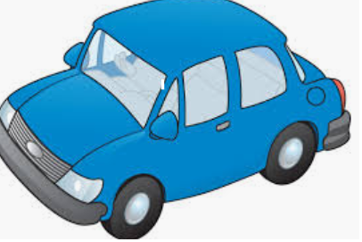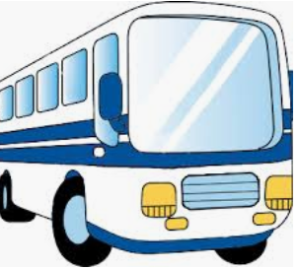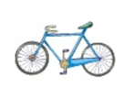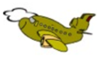
c__ __ __ __ s __i__ y __ ___ e p __ a __ e

2) Match, unscramble and colour.
r a c 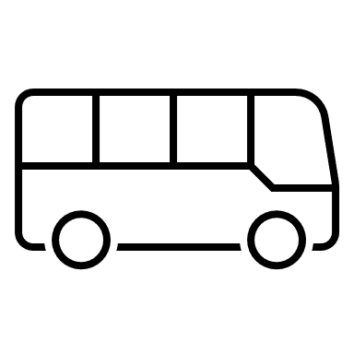
- _______________________

p a l n e
- ______________________
- _______________________
- ______________________
- _______________________
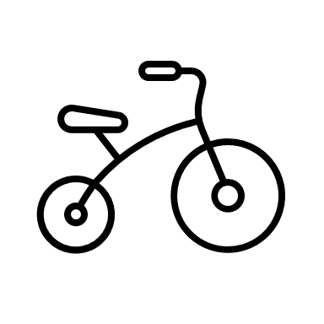
m t o r i b k e 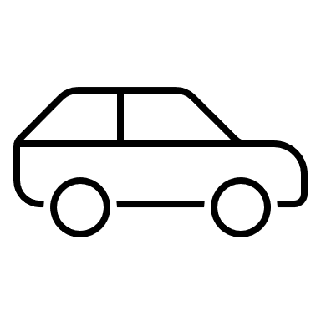

u s b 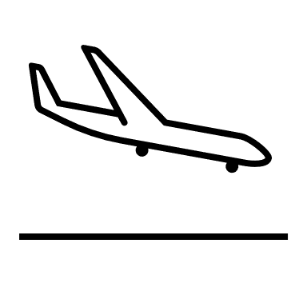
b c y i l e c 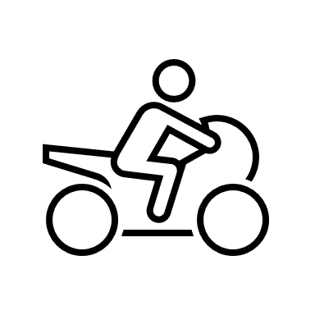

Answer key
- Car, bus, bicycle, plane
- Bus, car, bicycle, plane, motorbike

