Name: ____________________________ Surname: ____________________________ N^{ber}: ____ Grade/Class: _____
Assessment: _____________________________ | Date: ___________________________________________________
 | Teacher’s signature:  ___________________________ | Parent’s signature:  ___________________________

- Match.

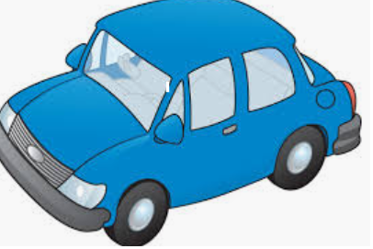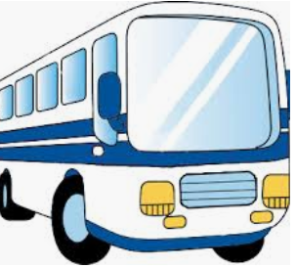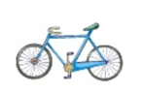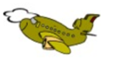

Plane bicycle car bus

2) Draw.

A blue bicycle A red car

A green bus A yellow motorbike

Answer key

- Car, bus, bicycle, plane

- drawing

