Name: ____________________________ Surname: ____________________________ N^{ber}: ____ Grade/Class: _____
Assessment: _____________________________ | Date: ___________________________________________________
 | Teacher’s signature:  ___________________________ | Parent’s signature:  ___________________________

- Match and write.
a)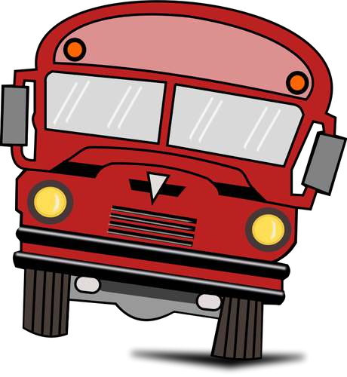 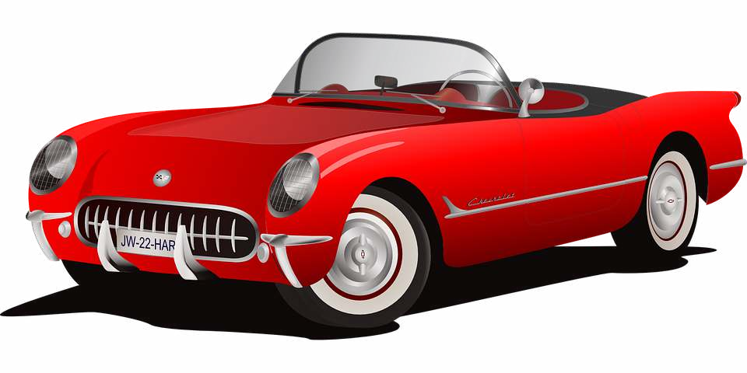b)
a plane
a car
a bike
a bus

c)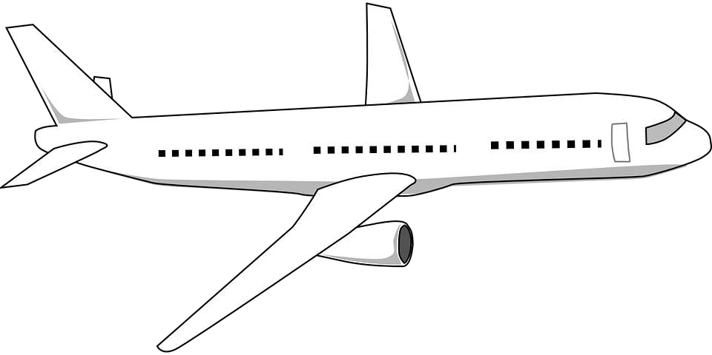 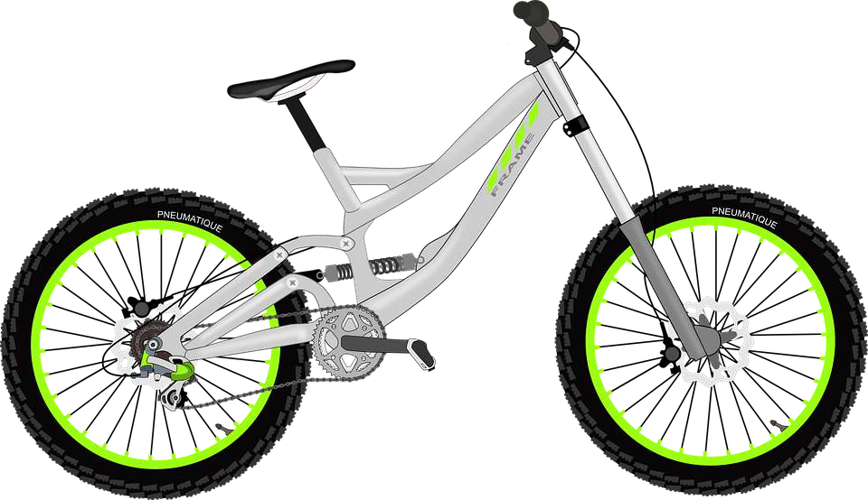d)

a) ____________________________________ b) ____________________________________

c) _____________________________________ d) _____________________________________

2) Arrange the words in the correct order.
a) It / car / a / is ____________________________________________
b) bike / I / my / ride/ ____________________________________________
c) is / It / plane / a _____________________________________________

Answer key
- a) a bus, b) a car, c) a plane, d) a bike
- a) It’s a car. B) I ride my bike. C) It’s a plane.

