Name: ____________________________ Surname: ____________________________ N^{ber}: ____ Grade/Class: _____
Assessment: _____________________________ | Date: ___________________________________________________
 | Teacher’s signature:  ___________________________ | Parent’s signature:  ___________________________

- Colour and write.
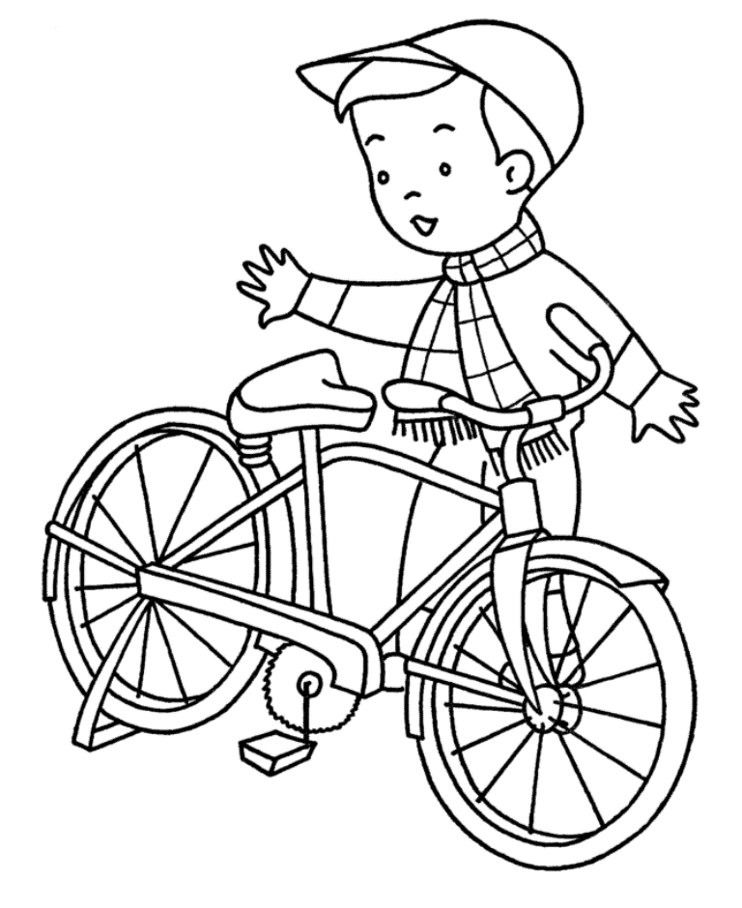
The boy rides a _________.

- Write.
- I go by _____________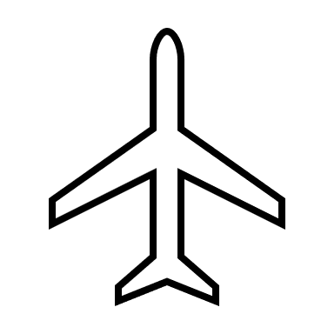
- You go by ______________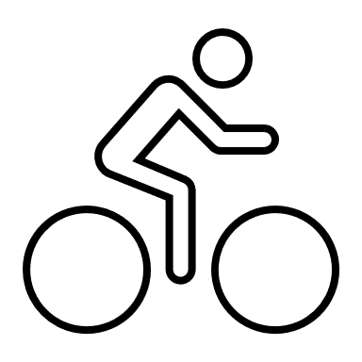
- They go by _______________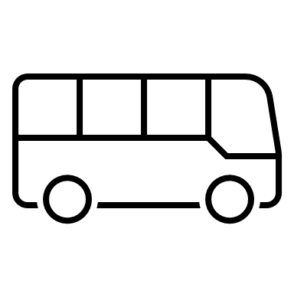
- We go by ______________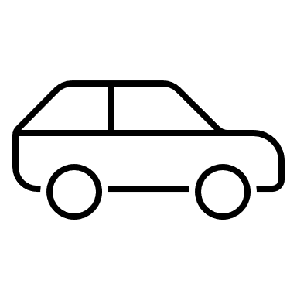

Answer key

- Bike
- A) plane, b) bike, c) bus, d) car

