Name: ____________________________ Surname: ____________________________ N^{ber}: ____ Grade/Class: _____
Assessment: _____________________________ | Date: ___________________________________________________
 | Teacher’s signature:  ___________________________ | Parent’s signature:  ___________________________

- Colour and tick.
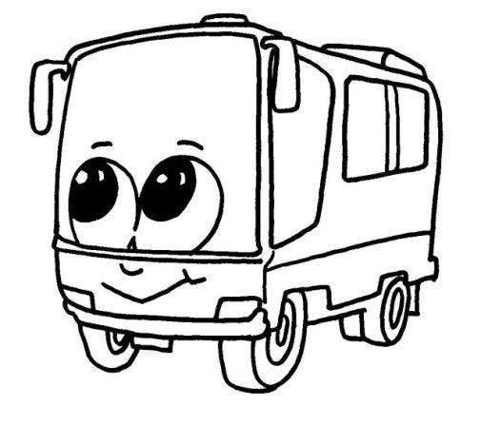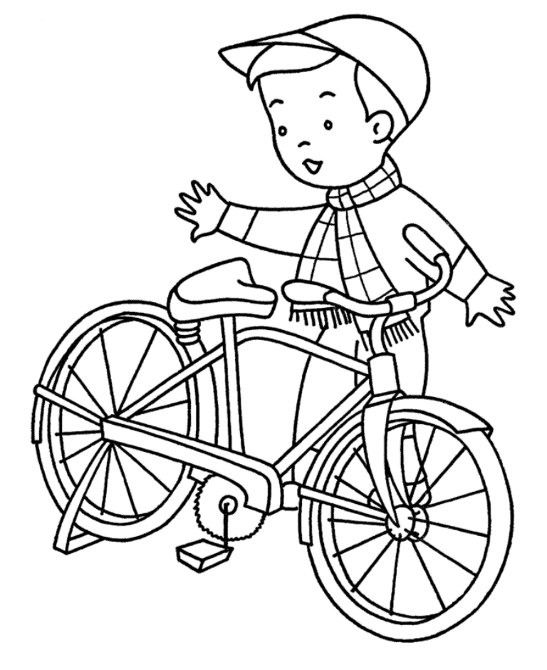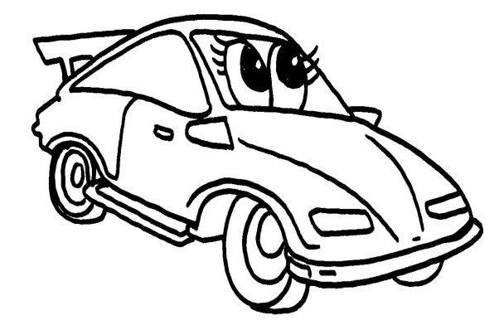
Jack Mike Jason

 | Bicycle | Car | bus
Jack
Mike
Jason

- Jack goes by ____________
- Mike goes by ____________
- Jason goes by ____________

2. Arrange the words.
a) Mike / bicycle / by / goes _____________________________
b) car / Jason / by / goes ______________________________
c) Jack / bus / by / goes ______________________________

Answer key
- A) Jack goes by bus. B) Mike goes by bicycle. C) Jason goes by car.
- A) Mike goes by bicycle. B) Jason goes by car. C) Jack goes by bus.

