Name: ____________________________ Surname: ____________________________N^{ber}: ____ Grade/Class: _____
Assessment: _____________________________ | Date: ___________________________________________________
 | Teacher’s signature:  ___________________________ | Parent’s signature:  ___________________________

- Listen and Tick (✅) or Cross (❌)

 | 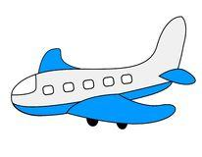 |  | 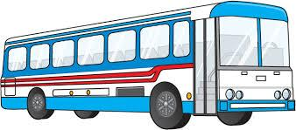 |  | 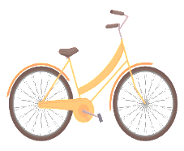
Max | ✅ |  | ❌
Stefanie
Lucy
Michael

2) Listen and write.
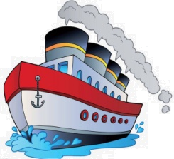

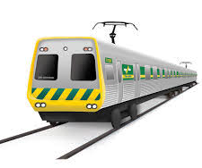

TRANSCRIPT

Exercise 1

1. Max is a pilot, he flies an airplane. He doesn’t like travelling by bus.

2. Stefanie likes cycling. She cannot fly an airplane or drive a car or bus.

3. Lucy likes to drive a car. She doesn’t like to ride a cycle

4. Michael drives a bus. He cannot fly an airplane.

EXERCISE 2

Write ‘L’ for Land Transport, ‘ W’ for Water transport and ‘A’ for Air transport

- Land Transport – Car, Truck, Motor Bike, Bicycle, Train
- Water transport – Sailboat, Ship
- Air Transport - Airplane

