Name: ____________________________ Surname: ____________________________N^{ber}: ____ Grade/Class: _____
Assessment: _____________________________ | Date: ___________________________________________________
 | Teacher’s signature:  ___________________________ | Parent’s signature:  ___________________________

- Listen and order.
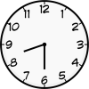
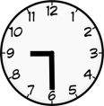
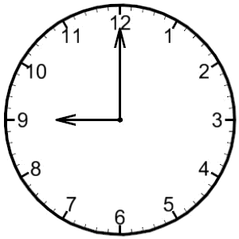

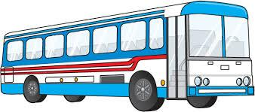

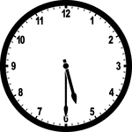

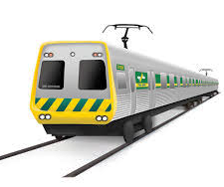

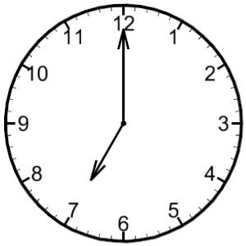
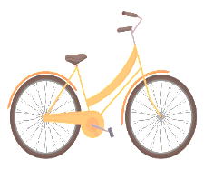

2) Complete:

Time | Vehicle Name
Nine o’ clock in the morning | __ a __
Half past eight in the morning | T __ __ __ __
Half past nine in the morning | __ o __ r __ __ k __
Half past five in the evening | C __ __ l __
Half past eight in the morning | __ u __

TRANSCRIPT

Exercise 1 and 2

1.
Ronnie travels to the office by car at nine o’ clock in the morning.

2.
Stella travels to the office early by half past seven o’ clock in the morning, as she travels by train every day.

3.
Ahmed takes his motorbike to the office and he leaves at half past nine in the morning.

4.
It’s half past five in the evening and it’s Nancy’s cycling time.

5.
Cara takes a bus to travel to her office. She leaves home at half past eight in the morning.

