Name: ____________________________ Surname: ____________________________N^{ber}: ____ Grade/Class: _____
Assessment: _____________________________ | Date: ___________________________________________________
 | Teacher’s signature:  ___________________________ | Parent’s signature:  ___________________________

- Listen and circle True or False

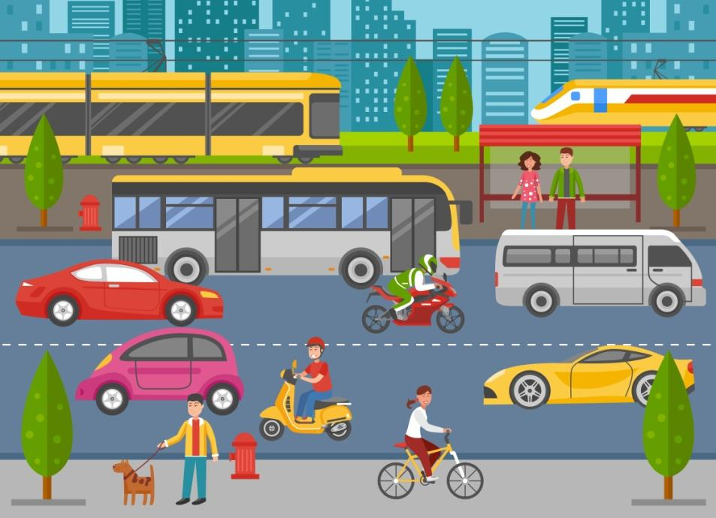

True/ False
True/ False

True/ False

True/ False

True/ False

- Listen and choose.

- School Bus Horse Boat

- Car Motor Bike Space Shuttle

- Train Boat Airplane

- Car Train Motorboat

- School bus Cycle Submarine

TRANSCRIPT

Exercise 1

Listen to the statements, then look at the picture and circle True/False based on your observations :

- There are five cars in the picture.
- The boy wearing a red helmet is riding a Scooter.
- The man, who’s wearing a green helmet, is driving a bus.
- There are two people standing at the bus stand.
- A girl is riding a bicycle on the footpath.

Exercise 2

Choose the appropriate option.
- You go to and from school in this.
- This has four wheels.
- This sails on water.
- This travels on a railway track.
- This can go underwater.

