Name: ____________________________ Surname: ____________________________N^{ber}: ____ Grade/Class: _____
Assessment: _____________________________ | Date: ___________________________________________________
 | Teacher’s signature:  ___________________________ | Parent’s signature:  ___________________________

- Listen and number.
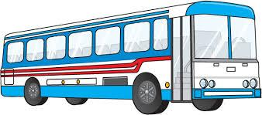

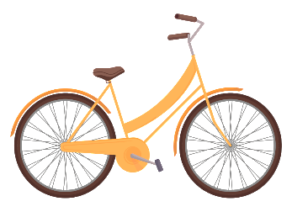
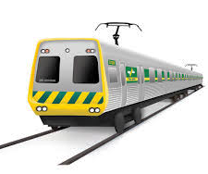
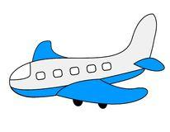
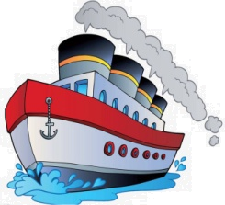

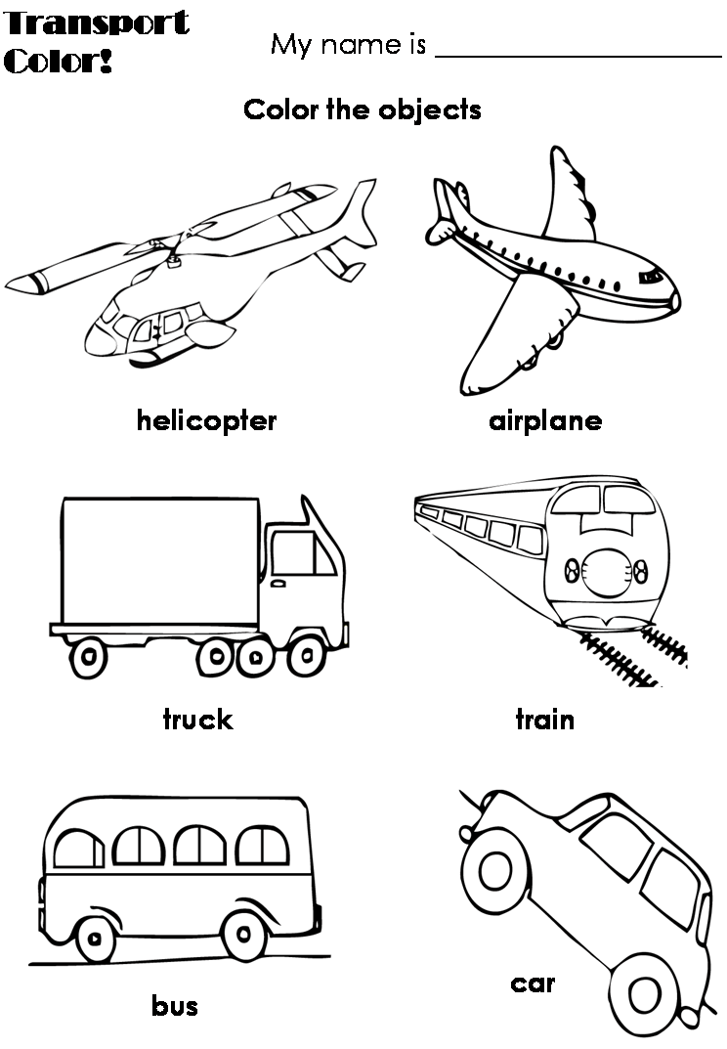
- Listen and colour.

TRANSCRIPT

EXERCISE 1

- A small vessel for travelling over water
- A large vehicle that takes many passengers to places
- A motor vehicle with four wheels
- A motor vehicle with two wheels and a strong frame
- A machine that flies in the sky
- A very large boat
- Pulls railroad cars along a track

EXERCISE 2

Colour the following vehicles only.

- Airplane
- Car
- Bus

