|  |  |  |
| --- | --- | --- |
| **Name:** ____________________________ **Surname:** ____________________________**Nber: ____ Grade/Class:** _____ | | |
| **Assessment:** _____________________________ | **Date:** ___________________________________________________ | |
| **Teacher’s signature:**  **___________________________** | **Parent’s signature:**  **___________________________** |

1. **Listen and Tick.**
2. 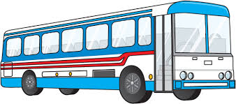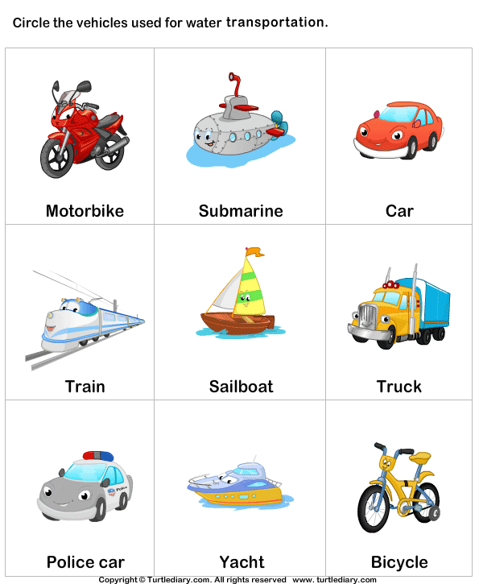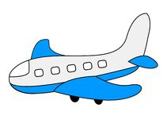

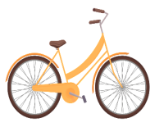



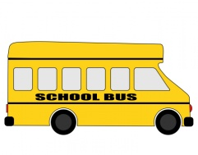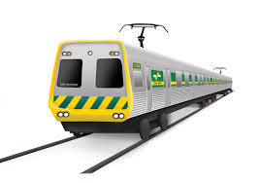

1. 



1. 







**TRANSCRIPT**

**EXERCISE 1**

Listen to the rhymes and choose the vehicle mentioned in each rhyme.

**ONE**

The wheels on the bus go round and round  
Round and round  
Round and round  
The wheels on the bus go round and round  
All through the town

**TWO**

Driving, driving in my car,  
Going very far,  
Down the street in my car.

**THREE**

I ride my little bicycle

I ride it to the shop

and when I see the

big red light I know

I have to stop

**FOUR**

Puff a train; puff a train,  
Noisy little puff a train.  
If you are going to the sea,  
Puff a train; oh please take me,  
Puff-a, puff-a, puff-a,  
Chook, chook, chook, chook, coooo!

**FIVE**

Row, row, row your boat  
Gently down the stream  
Merrily merrily, merrily, merrily  
Life is but a dream

**SIX**

The big ship sails on the ally-ally-oh

The ally-ally-oh, the ally-ally-oh

Oh, the big ship sails on the ally-ally-oh

On the last day of September.

**SEVEN**

I'm a little airplane,

Now watch me fly!

Here are my instruments

From down low to up high.