Name: ____________________________ Surname: ____________________________ N^{ber}: ____ Grade/Class: _____
Assessment: _____________________________ | Date: ___________________________________________________
 | Teacher’s signature:  ___________________________ | Parent’s signature:  ___________________________

- Read, write names and colour.

1. Adam is a pilot. He flies a plane. His plane is orange.
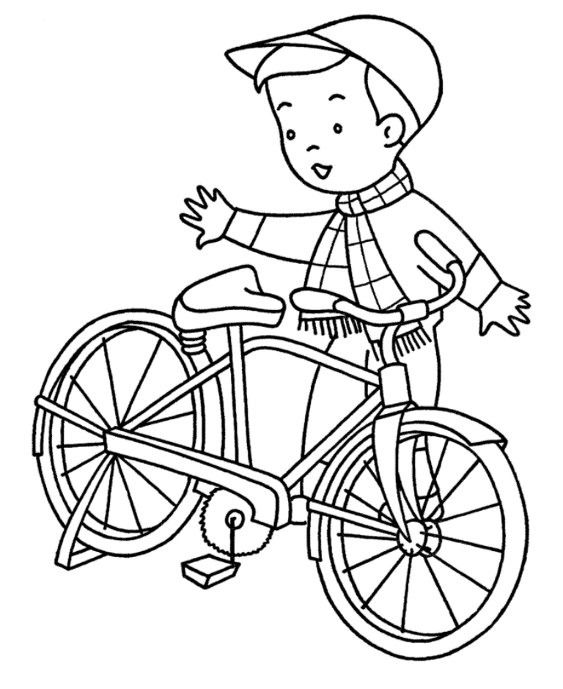
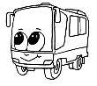
b) ____________
d) ____________
a) ____________
4. Wasim rides a bike. His bike is green.

2. Jeff is a bus driver. He drives s bus. His bus is red.

3. Marie drives a car. Her car is yellow.

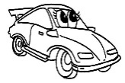
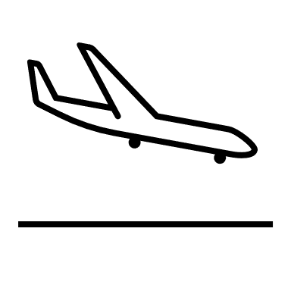
c) ____________

2) Read and circle the ones from the text.

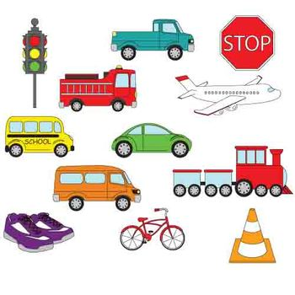
Hi. I’m Alice. I usually go to school by bus. I sometimes walk to school. I ride a bike after school. My father flies a plane. He’s a pilot.

Answer key

- A) Wasim; b) Jeff; c) Marie; d) Adam

- Circle: bus, shoes, bike, plane.

