Name: ____________________________ Surname: ____________________________ N^{ber}: ____ Grade/Class: _____
Assessment: _____________________________ | Date: ___________________________________________________
 | Teacher’s signature:  ___________________________ | Parent’s signature:  ___________________________

Read the text.

Kamala: How do you go to school?
Richard: I ride a bike to school.
Kamala: Do you often ride a bike?
Richard: Yes, I do. I ride my bike every day.
How do you go school?
Kamala: I usually walk to school.
Richard: Great! Let’s go together.

- Complete the table.
 | 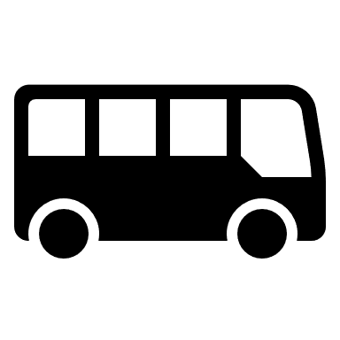 | 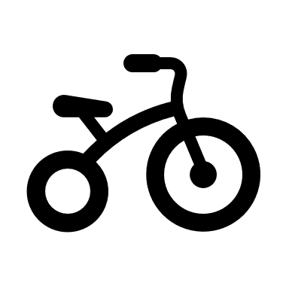
Richard
Kamala

- Read and write Yes or No.
- Richard usually rides a bike to school.
- Kamala usually goes to school by bus.
- Richard usually walks to school.
- Kamala rides a bike to school.

Answer key

1.
Richard |  | X
Kamala |  |  | X

2. a-T; b-T; c-F d-T.

