Name: ____________________________ Surname: ____________________________ N^{ber}: ____ Grade/Class: _____
Assessment: _____________________________ | Date: ___________________________________________________
 | Teacher’s signature:  ___________________________ | Parent’s signature:  ___________________________

- Read, circle and colour.
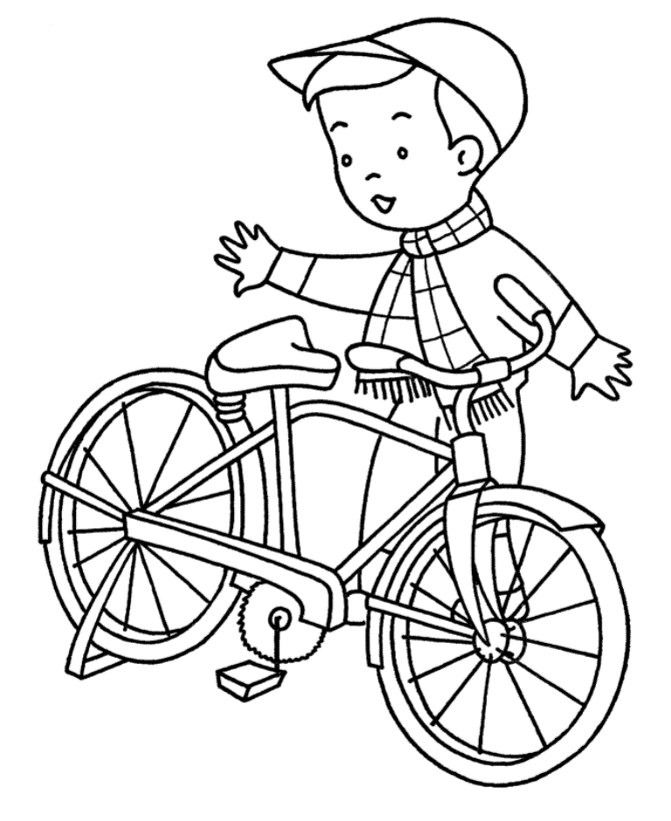
Hi, I’m Donald. I go to school by bike/bus. My bike is red. I like to ride/drive a bike. My mother likes to ride/drive a car. My father is a pilot. He drives/flies a plane.

- Read and draw.

a yellow car an orange plane

A red bike a blue bus

Answer key

- Bike, ride, drive, flies

- drawing

