Name: ____________________________ Surname: ____________________________ N^{ber}: ____ Grade/Class: _____
Assessment: _____________________________ | Date: ___________________________________________________
 | Teacher’s signature:  ___________________________ | Parent’s signature:  ___________________________

Look at the picture.

Answer the questions.

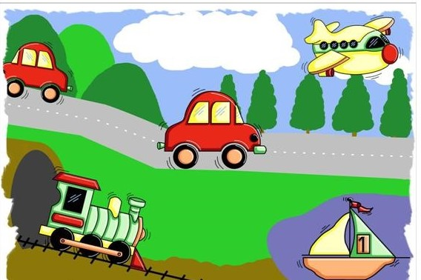

- Teacher’s questions:
- What can you see on the picture?
- How many cars are there?
- What color are the cars?
- What color is the plane?
- What is in the water?

- How do you like to travel? Why?
Answer key

- a) There are cars, plane, ship and train.
b) There are 2 cars.
c) The cars are red.
d) The plane is yellow.
e) The ship is in the water.

- I like to travel by…. because ……

