Name: ____________________________ Surname: ____________________________ N^{ber}: ____ Grade/Class: _____
Assessment: _____________________________ | Date: ___________________________________________________
 | Teacher’s signature:  ___________________________ | Parent’s signature:  ___________________________

Look at the picture.

Answer the questions.

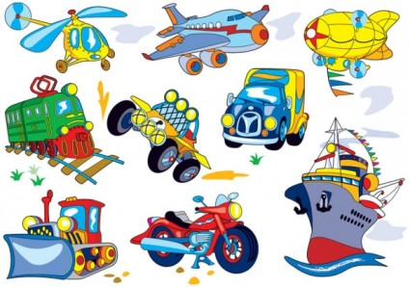

Teacher’s questions:
- Say the transportation you know in the picture.
- What do you like the most in the picture?
- Do you like to travel?

Answer key

- (The teacher points the plane, the car, the train, the ship) It is a car, a plane, a ship, a train.

- I like ….

- Yes/No

