Name: ____________________________ Surname: ____________________________ N^{ber}: ____ Grade/Class: _____
Assessment: _____________________________ | Date: ___________________________________________________
 | Teacher’s signature:  ___________________________ | Parent’s signature:  ___________________________

Look at the picture.

Answer the questions.
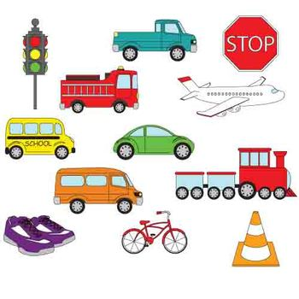

Teacher’s questions:
- Say the transportation in the picture.
- How do you go to school?

Answer key

- It’s a bus, a car, a bike, a plane, a train.

- I go to school by ….

