Name: ____________________________ Surname: ____________________________ N^{ber}: ____ Grade/Class: _____
Assessment: _____________________________ | Date: ___________________________________________________
 | Teacher’s signature:  ___________________________ | Parent’s signature:  ___________________________

Look at the picture.

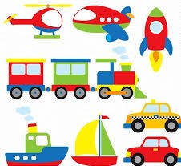

Teacher’s questions:
- What do you see on the picture?
- What color is the rocket?
- What color is the sailboat?
- What color is the helicopter?
- How do you like to travel?

Answer key

a) I can see a helicopter, a plane, a rocket, a train, a ship, a sail boat, and two cars.
b) The rocket is green, red and blue.
c) The sailboat is yellow, green and red.
d) The helicopter is yellow, red and blue.
e) I like to travel by…..

