Name: ____________________________ Surname: ____________________________ N^{ber}: ____ Grade/Class: _____
Assessment: _____________________________ | Date: ___________________________________________________
 | Teacher’s signature:  ___________________________ | Parent’s signature:  ___________________________

Look at the picture.

Answer the questions.

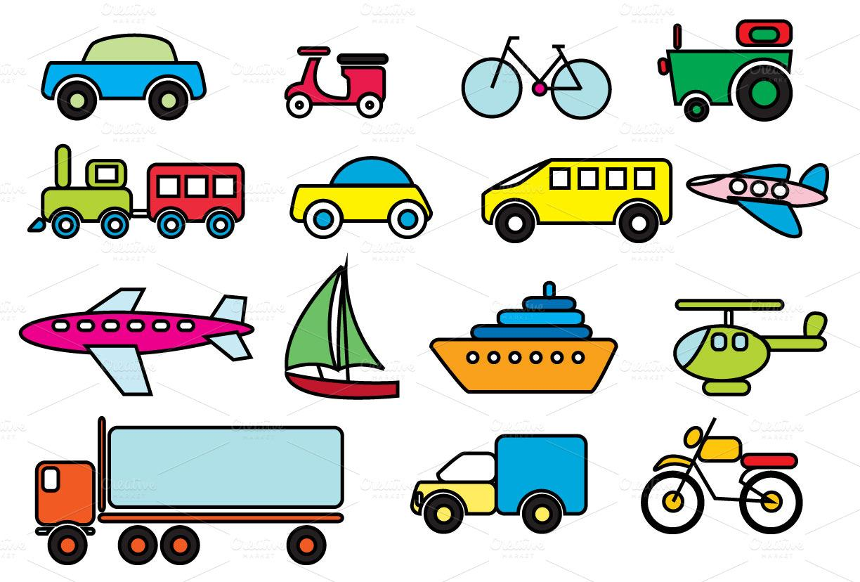

Teacher’s questions:
- Say the transportation in the picture.
- How do you travel?

Answer key

a) (The teacher points at the plane, the car, the train, the ship….) It is a car, a plane, a ship, a train…

b) I travel by ….

