Name: ____________________________ Surname: ____________________________ N^{ber}: ____ Grade/Class: _____
Assessment: _____________________________ | Date: ___________________________________________________
 | Teacher’s signature:  ___________________________ | Parent’s signature:  ___________________________

- Write and match.
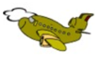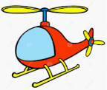
- b __ s
- h __ l __ __o __ t __ r
- c __ __
- b__ __t
- b __ __y__ __ e
- t__ a__ n
- p __ __ n __
- s h __ __

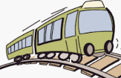

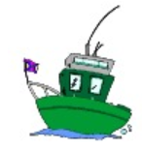

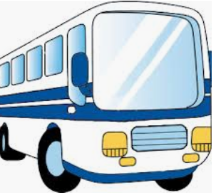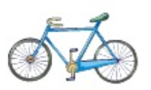

2) Answer.
How do you go to school? I go to school by __________________.

Answer key

- Bus, helicopter, car, boat, bicycle, train, plane, ship

- I go to school by ..... (answer may vary)

