Name: ____________________________ Surname: ____________________________ N^{ber}: ____ Grade/Class: _____
Assessment: _____________________________  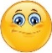  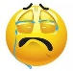 | Date: ___________________________________________________
 | Teacher’s signature:  ___________________________ | Parent’s signature:  ___________________________

- Label the pictures.

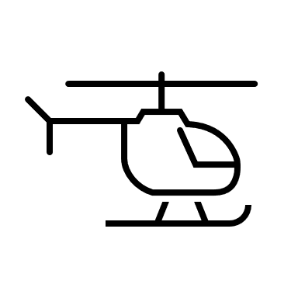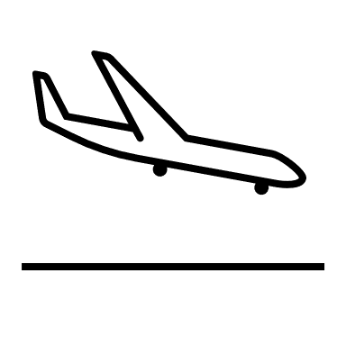

h_______________ b_______________ p _______________

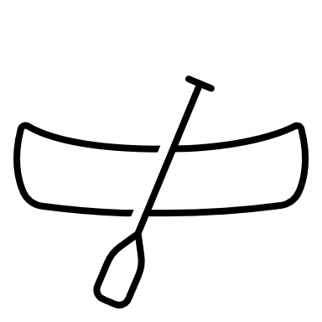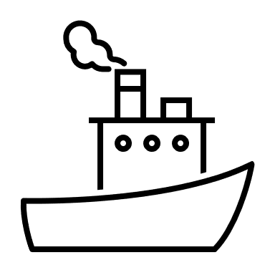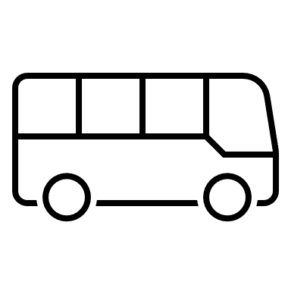
b_______________ s_______________ b_______________

- Colour.
- The boat is blue.
- The bus is red.
- The balloon is yellow.
- The helicopter is orange.
- The ship is green.
- The plane is grey.

Answer key

- Helicopter, balloon, plane, boat, ship, bus

- colouring

