Name: ____________________________ Surname: ____________________________ N^{ber}: ____ Grade/Class: _____
Assessment: _____________________________ | Date: ___________________________________________________
 | Teacher’s signature:  ___________________________ | Parent’s signature:  ___________________________

- Fill in the missing letters.
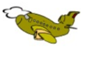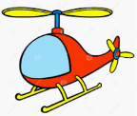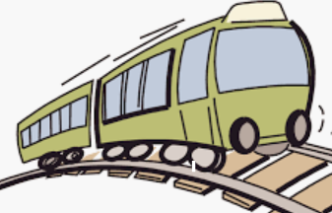
h_________

p_______________

t__________________
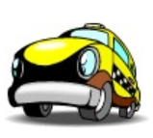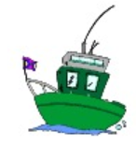

b___________
c________
s________________

b________________
b_______________

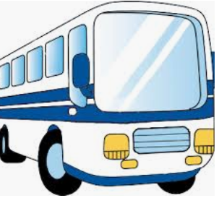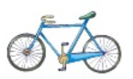

- Circle the right word.
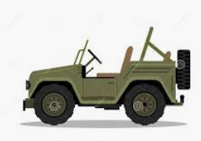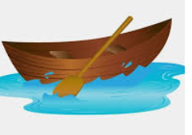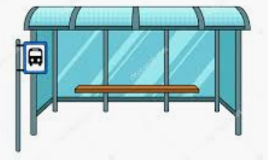
- bus a) ship a) train
- ship b) car b) bus
- car c) boat c) plane

Answer key
- plane, helicopter, train, car, boat, ship, bus, bicycle

- car, boat, bus

