Name: ____________________________ Surname: ____________________________ N^{ber}: ____ Grade/Class: _____
Assessment: _____________________________ | Date: ___________________________________________________
 | Teacher’s signature:  ___________________________ | Parent’s signature:  ___________________________

- Unscramble.

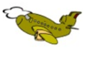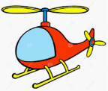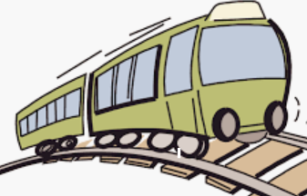
l a p e n ____________ e h I i p c o e r t _______________ r t a n i _____________

r a c________ 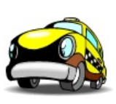 t a b o ___________ 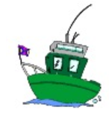

i s h p ____________
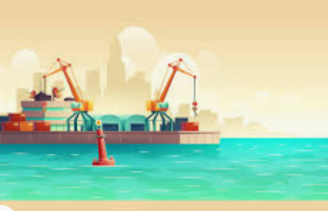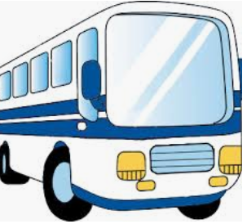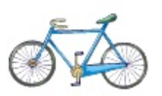

s u b ____________ b c c y l i e ____________

- Find the words from question 1.
h | e | l | i | c | o | p | t | e | r
b | u | s | o | a | d | l | r | k | e
o | c | a | g | r | w | a | a | s | y
a | s | e | e | f | u | n | i | a | s
t | q | d | t | w | d | e | n | e | q
s | y | w | a | u | e | w | e | t | w
s | h | i | p | d | h | q | r | w | t
b | i | c | y | c | l | e | r | q | w

Answer key

- Plane, helicopter, train, car, boat, ship, bus, bicycle

h | e | l | i | c | o | p | t | e | r
b | u | s |  | a |  | l | r
o |  |  |  | r |  | a | a
a |  |  |  |  |  | n | i
t |  |  |  |  |  | e | n
s | h | i | p
b | i | c | y | c | l | e

