Name: ____________________________ Surname: ____________________________ N^{ber}: ____ Grade/Class: _____
Assessment: _____________________________  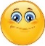  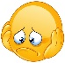  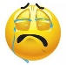 | Date: ___________________________________________________
 | Teacher’s signature:  ___________________________ | Parent’s signature:  ___________________________

- Circle the right word.

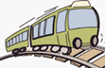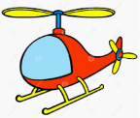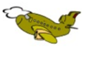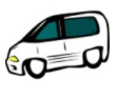
- train a) ship a) train a) plane
- car b) helicopter b) plane b) ship
- bus c) plane c) car c) car

- Find the words.
a h e l i c o p t e r f b u s o m o t o r b I k e g b a l l o o n e b i c y c l e w p l a n e h t r a i n s

- Label the pictures. Colour.
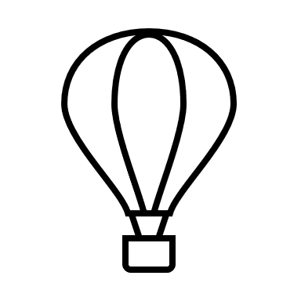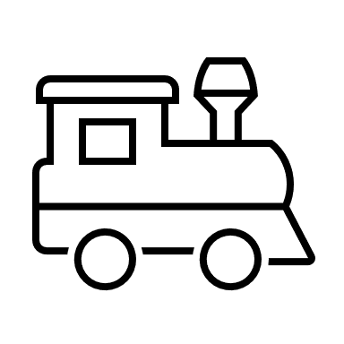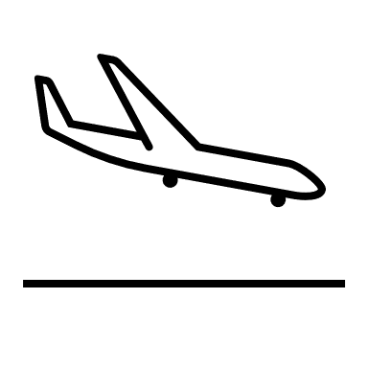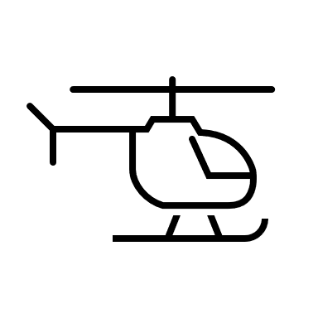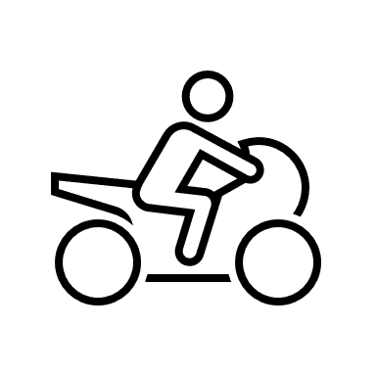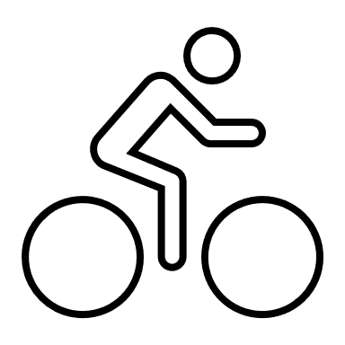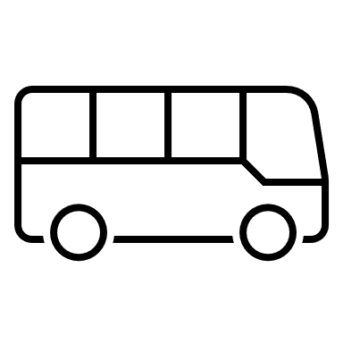
__________ ____________ _____________ _________ ___________ __________ ___________

Answer key
- Train, helicopter, plane, car

- h e l i c o p t e r b u s m o t o r b I k e b a l l o o n b i c y c l e p l a n e t r a i n

- balloon, train, plane, helicopter, motorbike, bicycle, bus

