Name: ____________________________ Surname: ____________________________ N^{ber}: ____ Grade/Class: _____
Assessment: _____________________________ | Date: ___________________________________________________
 | Teacher’s signature:  ___________________________ | Parent’s signature:  ___________________________

- Arrange the words in the correct order.

- go / They / to / work / by / 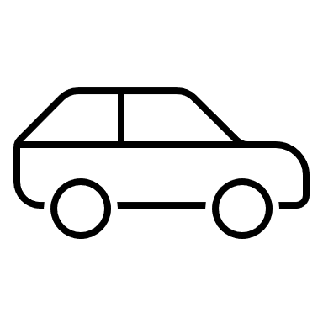
___________________________________________
- Molly / goes / work / by / / to
____________________________________.
____________________________________.
____________________________________.
____________________________________.

_____________________________________________
- Ann / to / work / 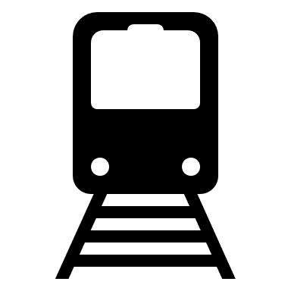 / by / goes
______________________________________________
- I / school / go / by / to /
_____________________________________________

2. Write short answers:
for example: Do you go to school by bus? Yes, I do.
- Do they go to school by bus? Yes, they _________
- Does he go to work by car? No, he _________
- Does she walk to school? Yes, she _________
- Do you travel by plane? No, I __________

Answer key
- A) They go to work by car. B) Molly goes to work by bus. C) Ann goes to work by train. D) I go to school by bus.
- Do, doesn’t, does, don’t

