Name: ____________________________ Surname: ____________________________ N^{ber}: ____ Grade/Class: _____
Assessment: _____________________________ | Date: ___________________________________________________
 | Teacher’s signature:  ___________________________ | Parent’s signature:  ___________________________

- Look and write.
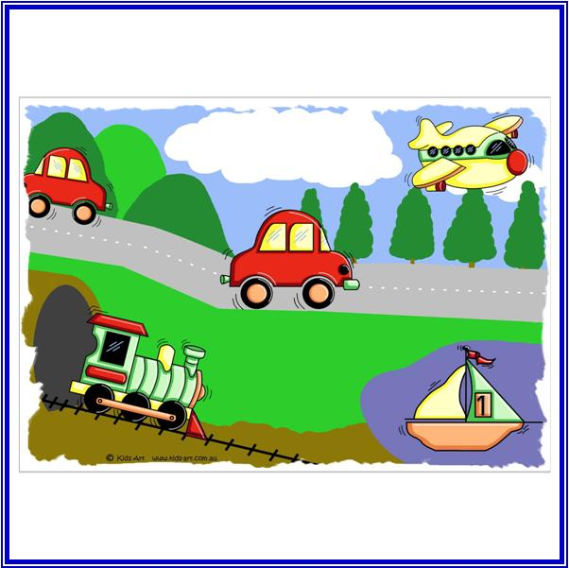
There are two red c________, a yellow p_____________ and a green t____________.

- How do they go?

a) Tom goes to work by 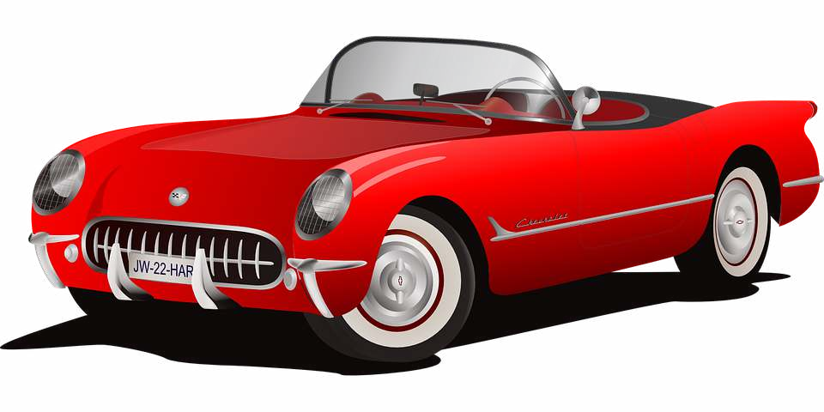 ____________________________________

b) Sally travels by 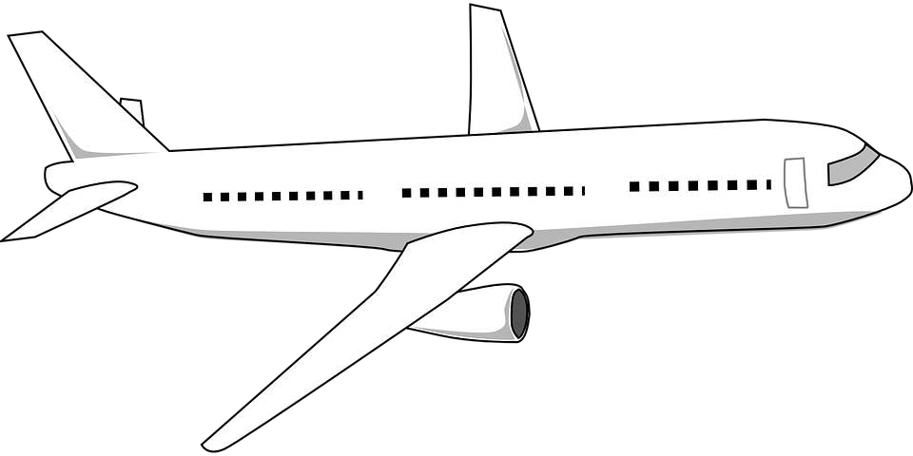 ____________________________________
c) Jack goes to school by 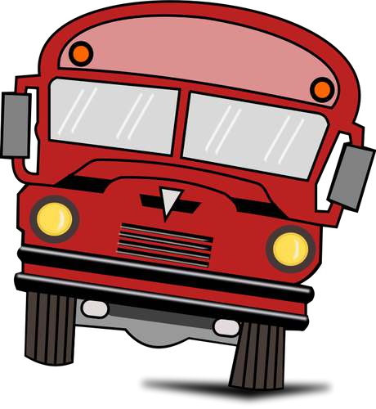 _____________________________________
d) I go to school by 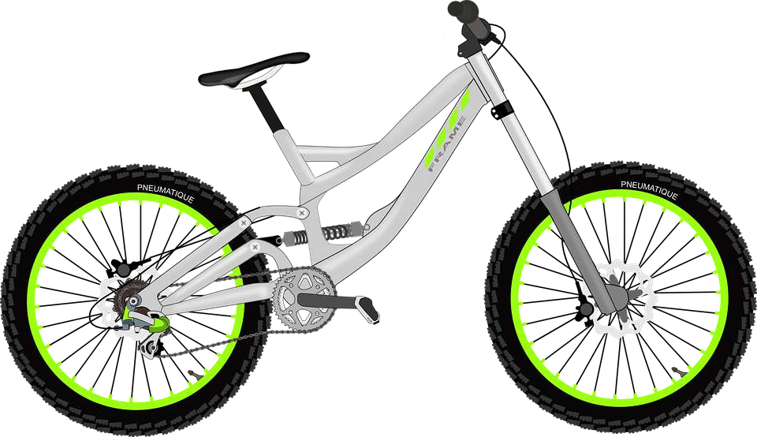 _____________________________________

Answer key

- There are two red cars, a yellow plane and a green train.
- Car, plane, bus, bike

