TOPIC: Nature | SUBTOPICS: Naming Nature | LEVEL: A1
Name: ____________________________ Surname: ____________________________ N^{ber}: ____ Grade/Class: _____

TOPIC: Transport | SUBTOPICS: Choose the correct transport | LEVEL: A1
Name: ____________________________ Surname: ____________________________ N^{ber}: ____ Grade/Class: _____
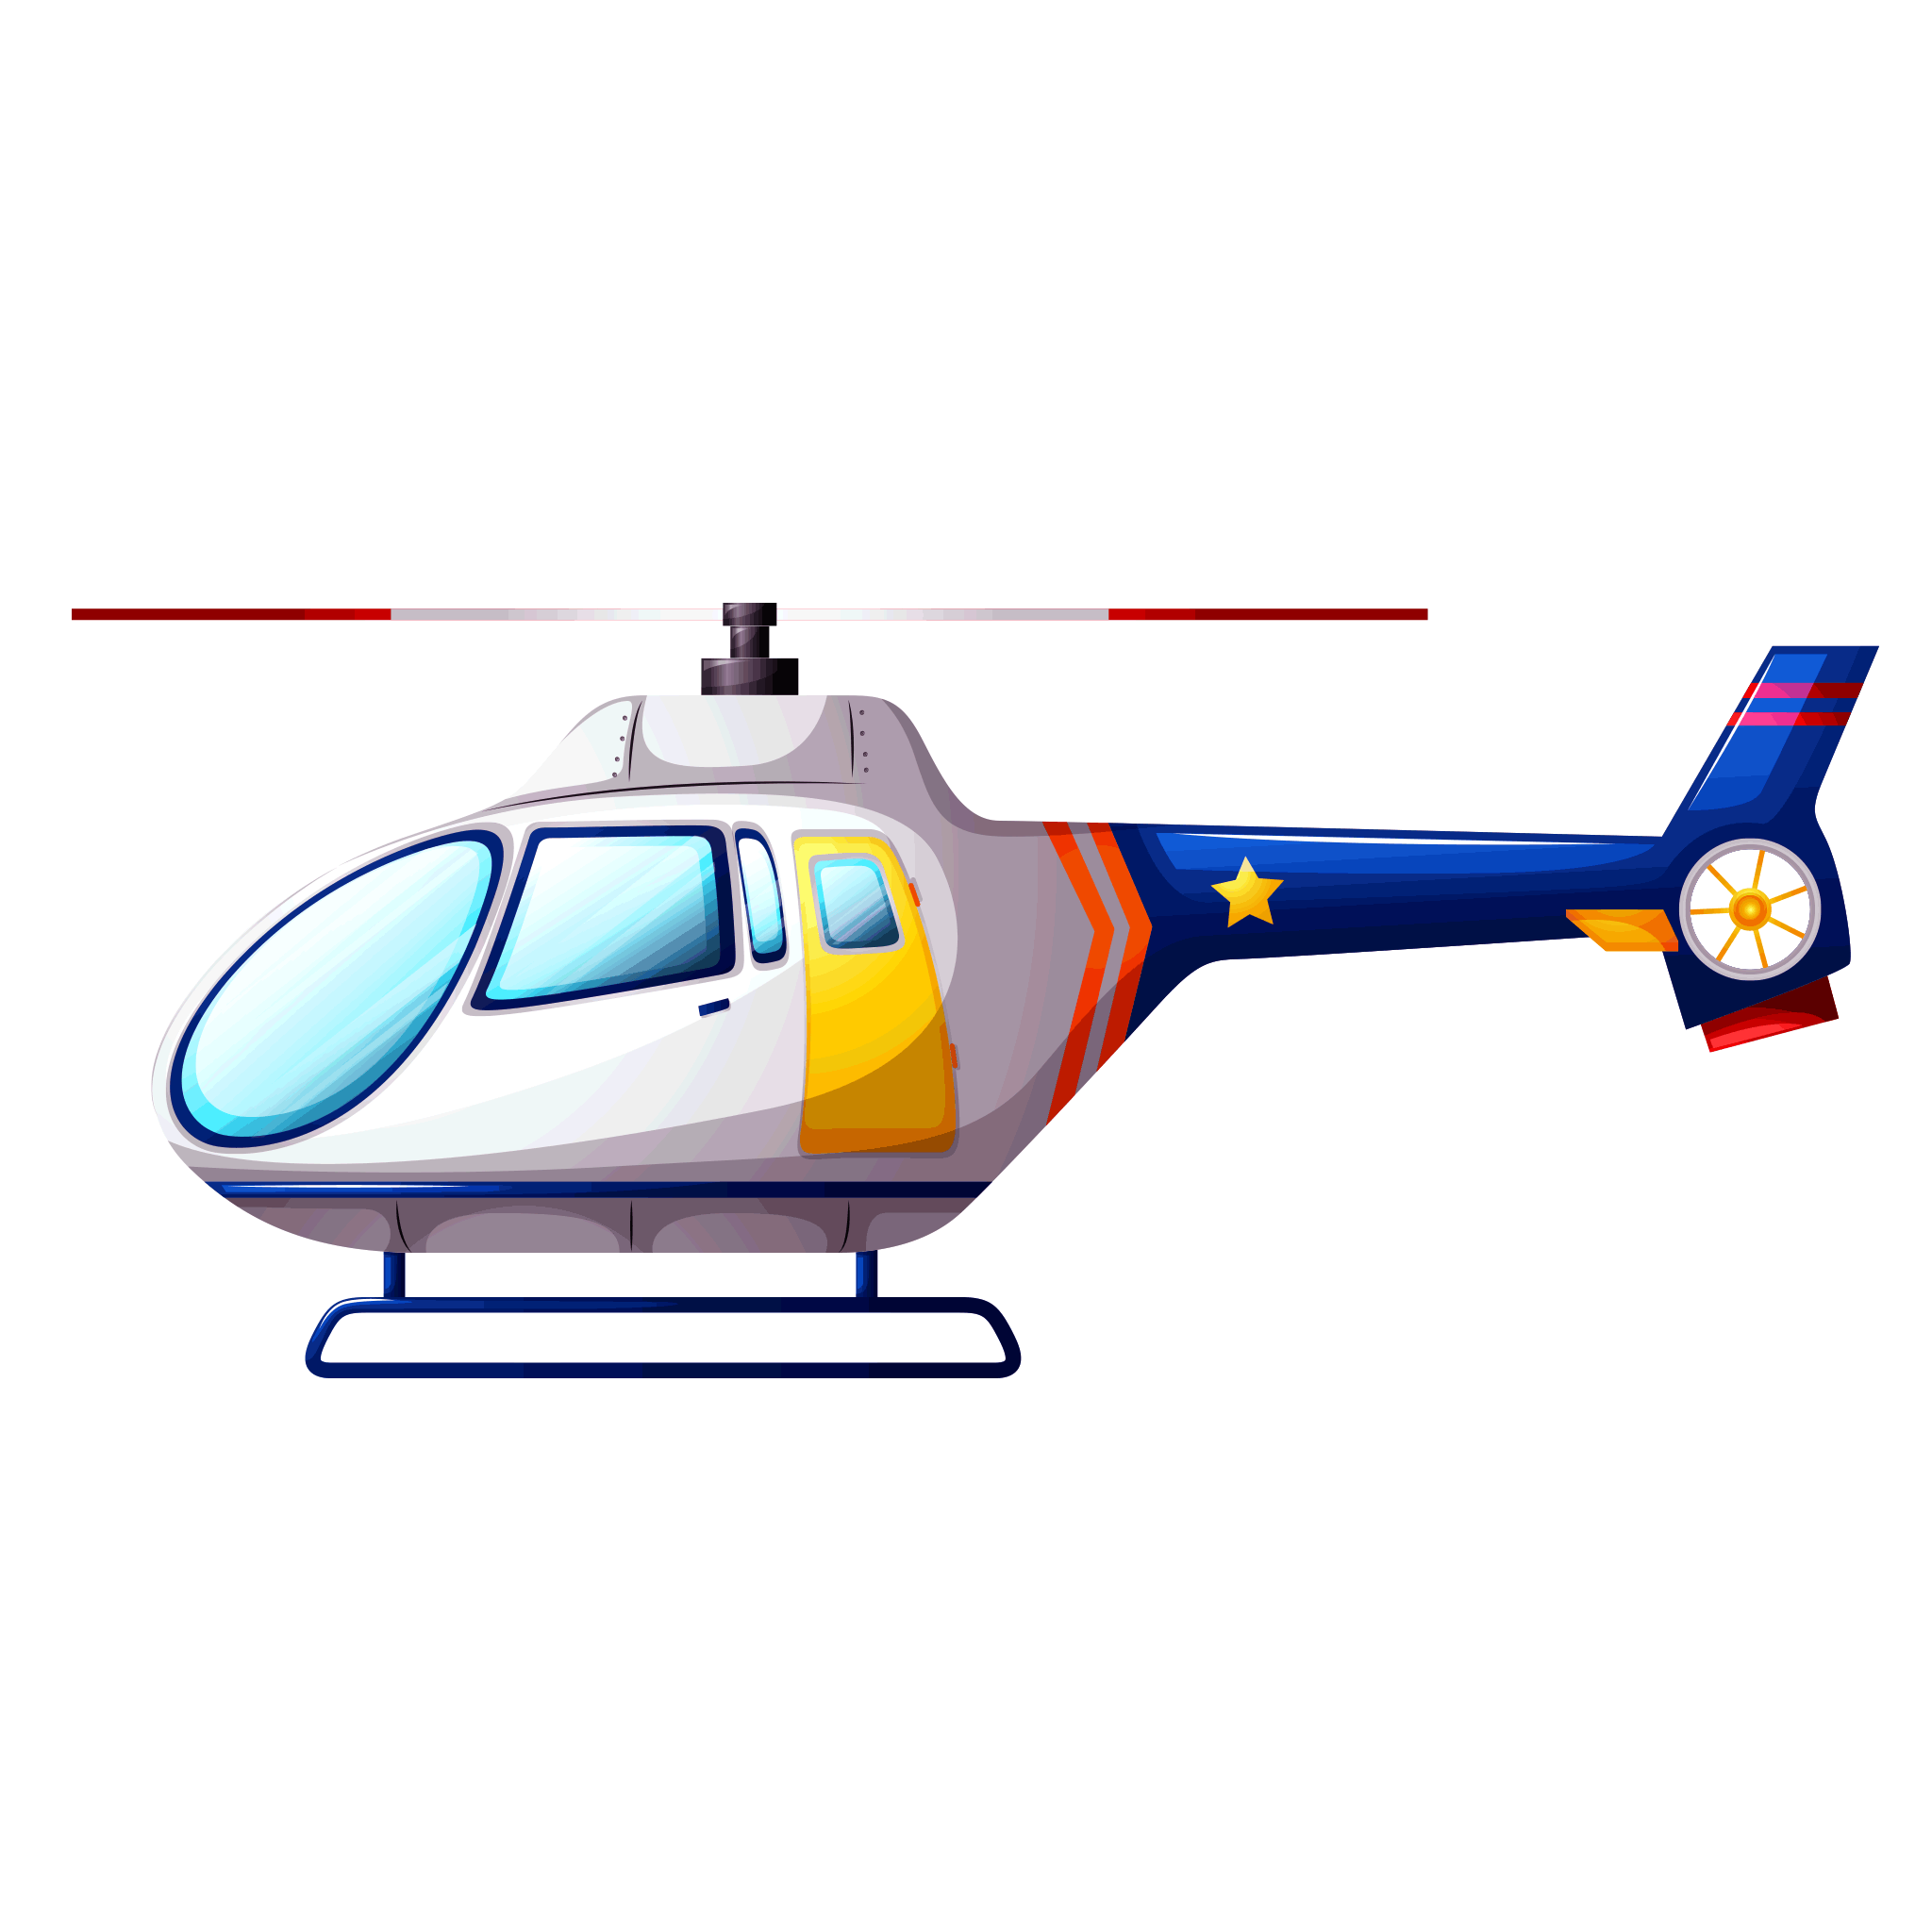
CHOOSE THE TRANSPORT
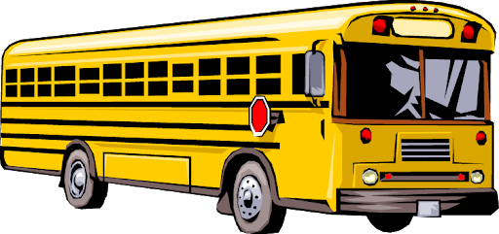
Look at the picture and encircle the correct option.
1.
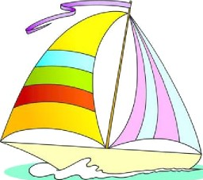
3.
2.

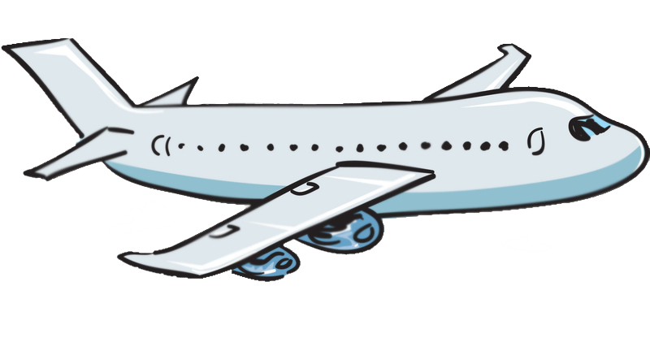
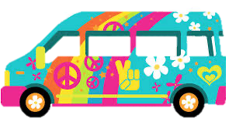
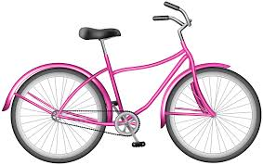
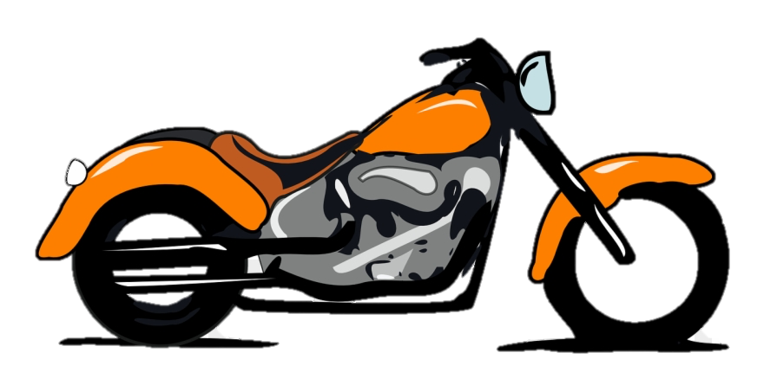
a. helicopter
b. truck
c. van
a. truck
b. bicycle
c. van
a. bicycle
b. bus
c. motorbike
a. airplane
b. bus
c. train
a. train
b. bus
c. bycicle
a. van
b. car
c. bus
9.
8.
7.
a. truck
b. bus
c. van
a. helicopter
b. school bus
c. train
a. ship
b. boat
c. van
6.
5.
4.

TOPIC: Transport | SUBTOPICS: MODE OF TRANSPORT | LEVEL: A1
Name: ____________________________ Surname: ____________________________ N^{ber}: ____ Grade/Class: _____
ANSWER KEY
CHOOSE THE TRANSPORT
Look at the picture and encircle the correct option.
1.
3.
2.

a. truck
b. bicycle
c. van
a. bicycle
b. bus
c. motorbike
a. airplane
b. bus
c. train
a. train
b. bus
c. bycicle
a. van
b. car
c. bus
9.
8.
7.
a. truck
b. bus
c. van
a. helicopter
b. school bus
c. train
a. ship
b. boat
c. van
6.
5.
4.

a. helicopter
b. truck
c. van

