TOPIC: Nature | SUBTOPICS: Naming Nature | LEVEL: A1
Name: ____________________________ Surname: ____________________________ N^{ber}: ____ Grade/Class: _____

TOPIC: Transport | SUBTOPICS: MODE OF TRANSPORT | LEVEL: A1
Name: ____________________________ Surname: ____________________________ N^{ber}: ____ Grade/Class: _____
MODE OF TRANSPORT
Select the correct mode of transport based on their category.

By Land | By Air | By Water
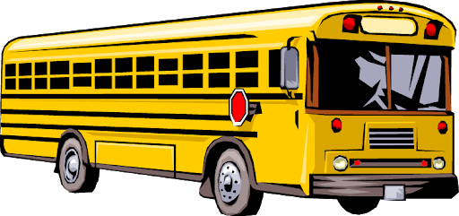
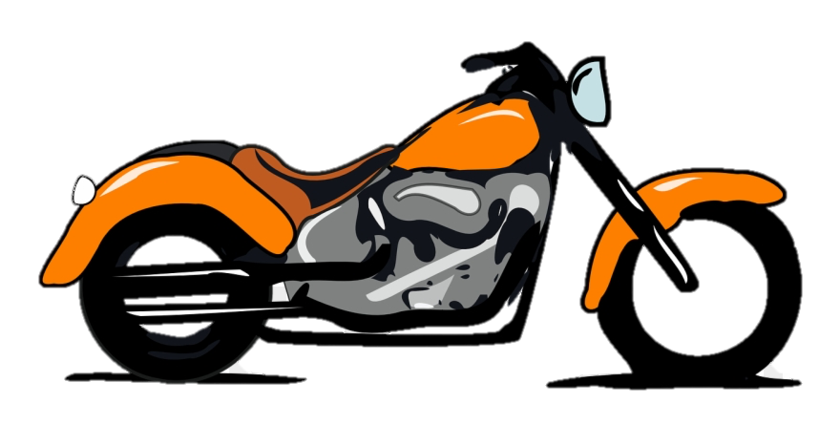
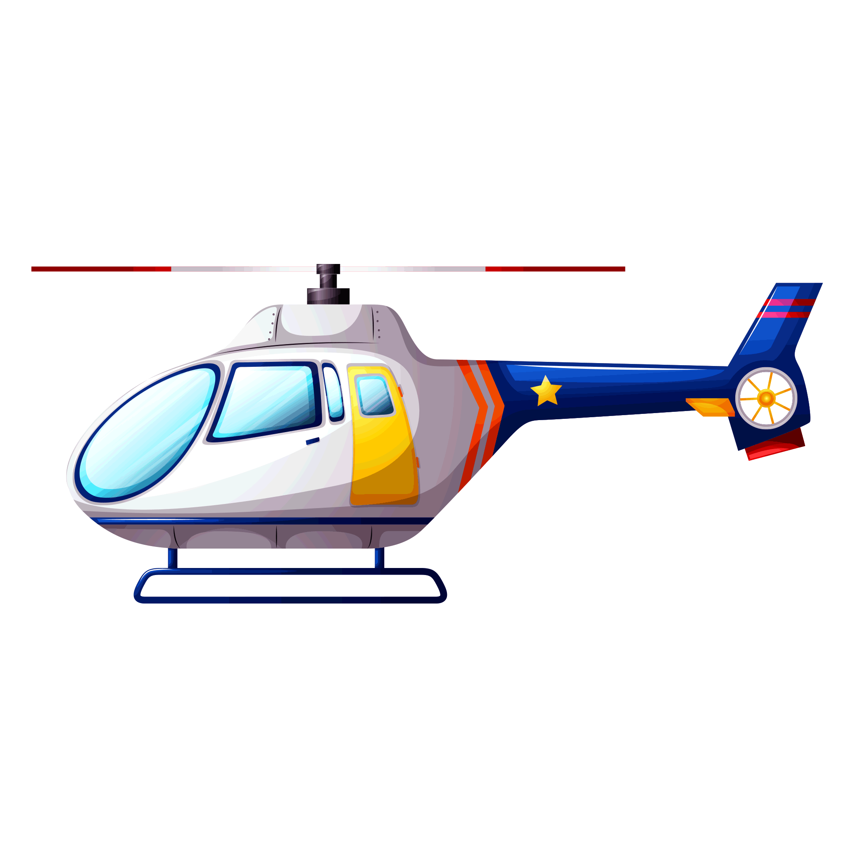
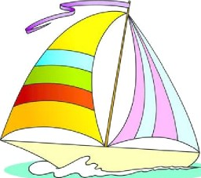
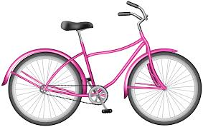
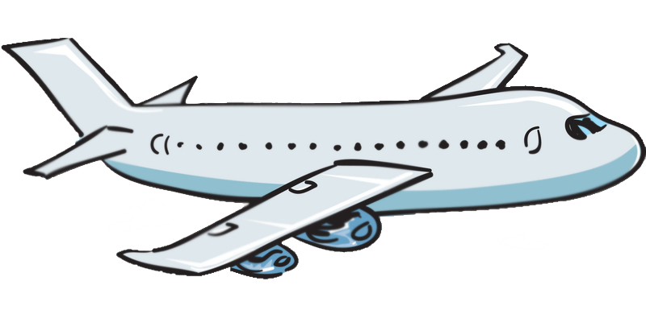
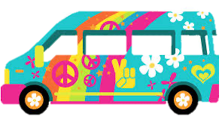
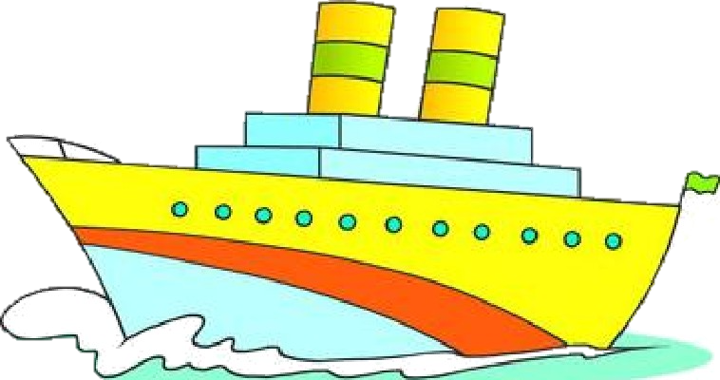
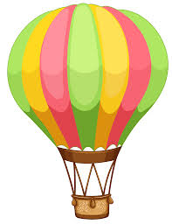
school bus
boat
van
hot air balloon
helicopter
car
bicycle
ship
motorbike
train
airplane

ANSWER KEY
MODE OF TRANSPORT
Select the correct mode of transport based on their category.

By Land | By Air | By Water
school bus | helicopter | boat
motorbike | airplane | ship
car | hot air balloon
train
van
bicycle | school bus  boat  van  hot air balloon  helicopter  car  bicycle  ship  motorbike  train  airplane

