TOPIC: Nature | SUBTOPICS: Naming Nature | LEVEL: A1
Name: ____________________________ Surname: ____________________________ N^{ber}: ____ Grade/Class: _____

TOPIC: Transport | SUBTOPICS: LOOP A WORD OF TRANSPORT | LEVEL: A1
Name: ____________________________ Surname: ____________________________ N^{ber}: ____ Grade/Class: _____
LOOP A WORD OF TRANSPORT
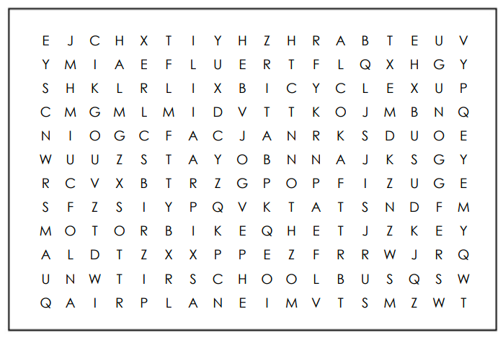

Find the following words in the puzzle.
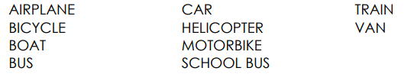

TOPIC: Transport | SUBTOPICS: COMPLETE THE MODE OF TRANSPORT | LEVEL: A1
Name: ____________________________ Surname: ____________________________ N^{ber}: ____ Grade/Class: _____
ANSWER KEY
LOOP A WORD OF TRANSPORT
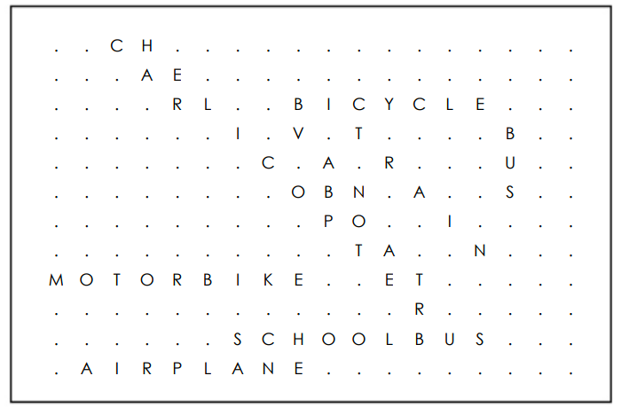

Find the following words in the puzzle.

