TOPIC: Nature | SUBTOPICS: Naming Nature | LEVEL: A1
Name: ____________________________ Surname: ____________________________ N^{ber}: ____ Grade/Class: _____

PICTURE MATCHING
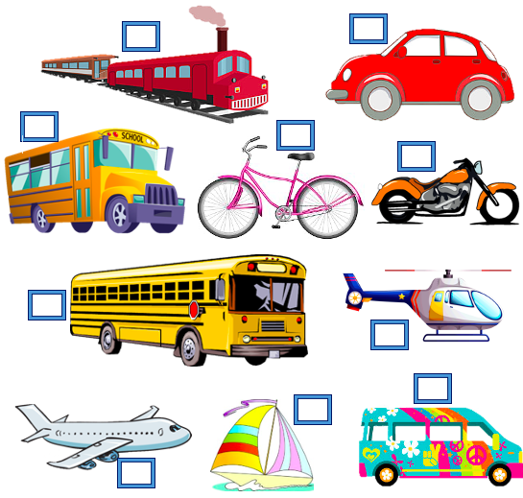
Match the words with the pictures.
TOPIC: Transport | SUBTOPICS: Match the Nature | LEVEL: A1
Name: ____________________________ Surname: ____________________________ N^{ber}: ____ Grade/Class: _____

1. school bus 2. boat 3. van
4. motorbike 5. bicycle 6. train
7. car 8. bus 9. helicopter 10. airplane

TOPIC: Transport | SUBTOPICS: Choose the correct transport | LEVEL: A1
Name: ____________________________ Surname: ____________________________ N^{ber}: ____ Grade/Class: _____
ANSWER KEY
PICTURE MATCHING
Match the words with the picture.
TOPIC: Transport | SUBTOPICS: Match the Nature | LEVEL: A1
Name: ____________________________ Surname: ____________________________ N^{ber}: ____ Grade/Class: _____
7
6

5
4
1

8
9
3
2

10

1. school bus 2. boat 3. van
4. motorbike 5. bicycle 6. train
7. car 8. bus 9. helicopter 10. airplane

