Ex. 1 A1 Weather
Name: ____________________________ Surname: ____________________________ N^{ber}: ____ Grade/Class: _____
Assessment: _____________________________ | Date: ___________________________________________________
 | Teacher’s signature:  ___________________________ | Parent’s signature:  ___________________________

Listen and write the type of weather next to the photo:
--------------------------------------------------------

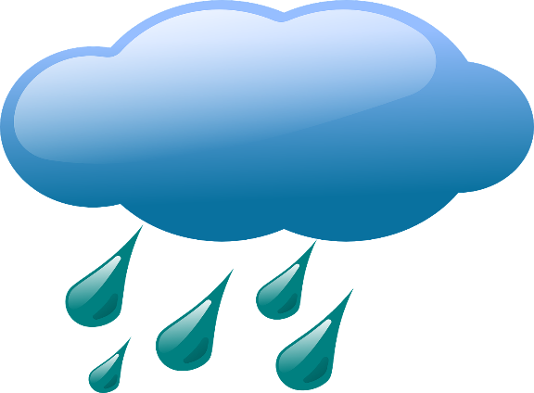 ----------------------------------------------------------
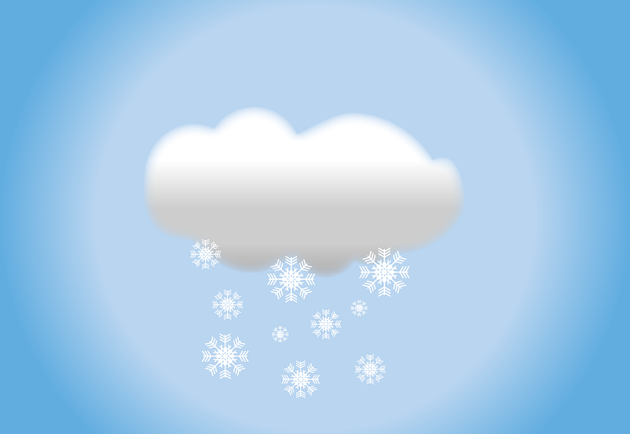------------------------------------------------------------
Sunny - cloudy - snowy

TRANSCIPT:
When there are high temperatures and it is very hot then the weather is ……SUNNY
When the sky is full of clouds and you cannot see the sun then it is ……..CLOUDY
When it is very cold and there is a lot of snow then the weather is ………SNOWY

