Exercise 2 A1 Weather
Name: ____________________________ Surname: ____________________________ N^{ber}: ____ Grade/Class: _____
Assessment: _____________________________ | Date: ___________________________________________________
 | Teacher’s signature:  ___________________________ | Parent’s signature:  ___________________________

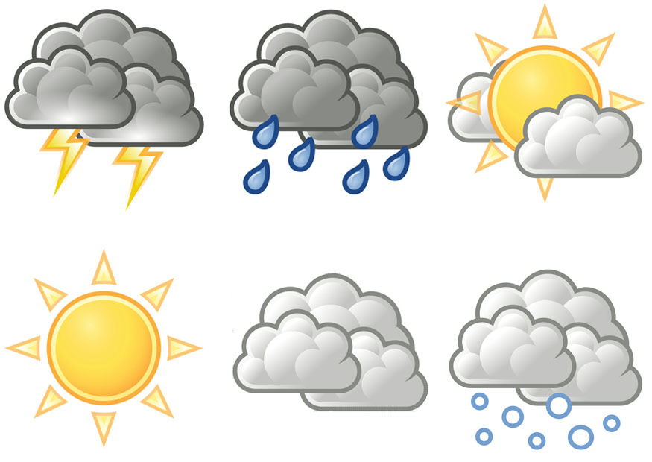

Listen and write what the weather will be like tomorrow.

It will be …………………………….. in the morning.
Then it will be ……………………… in the afternoon.
It will ………………at night.

Key: 1. Sunny 2. Cloudy 3. Rain

Transcript:
Well, tomorrow, we will have a sunny day in the morning but later it will be cloudy in the afternoon.
At night, it will be even worse as it will rain heavily….

