Ex. 3 A1 Weather
Name: ____________________________ Surname: ____________________________ N^{ber}: ____ Grade/Class: _____
Assessment: _____________________________ | Date: ___________________________________________________
 | Teacher’s signature:  ___________________________ | Parent’s signature:  ___________________________

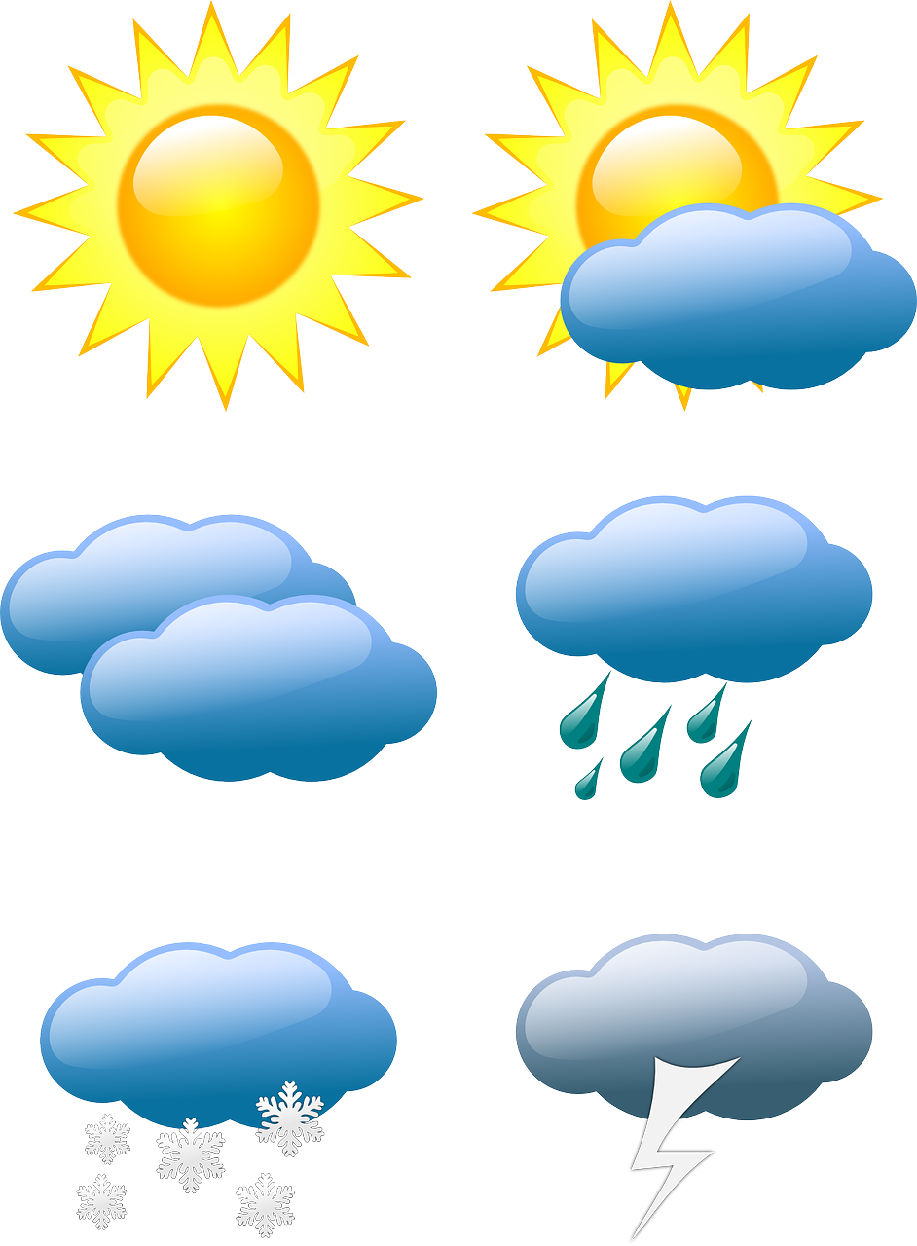

Listen and write the correct spelling in the following weather words by filling in the missing letters
- C_ _ _D_

- R_ _ N_

- S_ _ N_

- S_ _W_

- T_ _N_ _R

Transcript:
Spell out loudly the following words:
- C L O U D Y
- R A I N Y
- S U N N Y
- S N O W Y
- T H U N D E R

