Ex, 5 A1 Weather
Name: ____________________________ Surname: ____________________________ N^{ber}: ____ Grade/Class: _____
Assessment: _____________________________ | Date: ___________________________________________________
 | Teacher’s signature:  ___________________________ | Parent’s signature:  ___________________________

Listen and draw lines to the right picture.

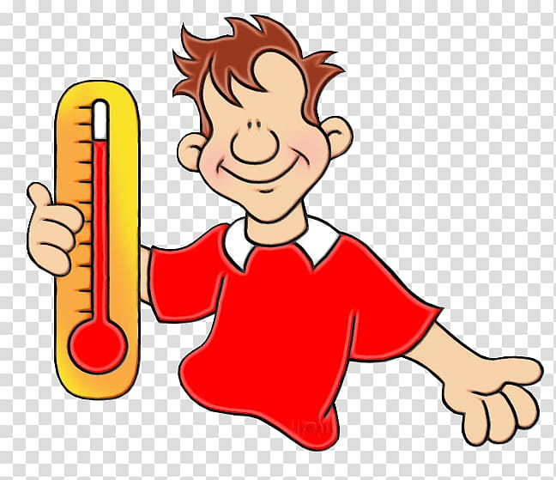 Paul

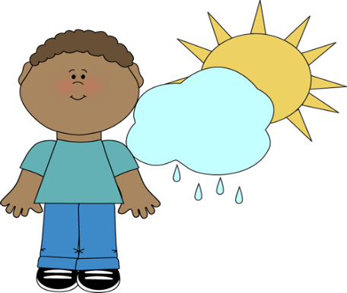 Nick
Peter

Key : 1. Nick 2. Paul 3. Peter

Transcript:

It’s snowing in England today. Nick is feeling freezing cold.
It’s a sunny day today in France but with some rain later on. Paul is feeling nice.
It’s extremely hot in Spain today. Peter is smiling and ready to go swimming.

