Exercise 1 A1 Weather
Name: ____________________________ Surname: ____________________________ N^{ber}: ____ Grade/Class: _____
Assessment: _____________________________ | Date: ___________________________________________________
 | Teacher’s signature:  ___________________________ | Parent’s signature:  ___________________________

It’s the weekend and Mary has no homework to do. It’s time to wake up and check the weather for the week. There’s a storm today. There will be a storm and it will rain on Saturday.
On Sunday, the temperature will drop and there will be snow.
What about Monday, Tuesday, Wednesday, Thursday and Friday? Will it be cloudy, sunny or rainy?
Match the weather words to the following weekdays:

sunny / snowy / stormy / cold / rainy /
1. Monday-------------- 2. Tuesday………………
3. Wednesday -------- 4. Thursday------------- 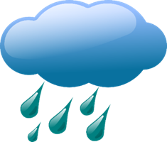
5. Friday------------------

Key: 1. Snowy 2. Cold 3. Stormy 4. Rainy 5. Sunny

