Exercise 2 A1 Weather
Name: ____________________________ Surname: ____________________________ N^{ber}: ____ Grade/Class: _____
Assessment: _____________________________ | Date: ___________________________________________________
 | Teacher’s signature:  ___________________________ | Parent’s signature:  ___________________________

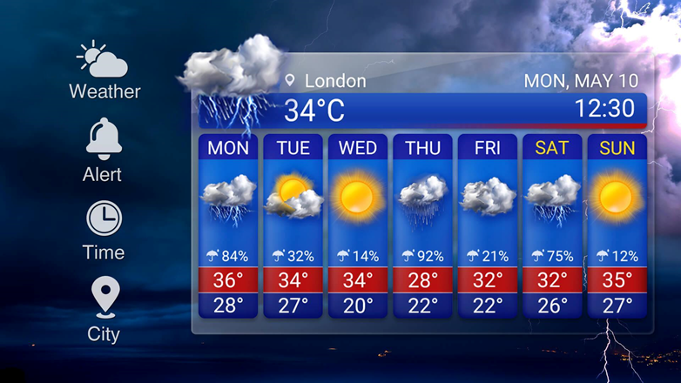

Look at the following weather forecast for London for next week and answer the questions by writing YES or NO.

1. Will the weather be sunny on Monday? -------2.Will the weather be rainy on Tuesday? ----
3. Will the weather be sunny on Wednesday? -------4.Will the weather be windy on Thursday? -------- 5. Will the weather be cloudy on Friday? --------
6. Will the weather be rainy on Saturday?---------7.Will the weather be snowy on Sunday?----

Key: 1.no 2.no 3.yes 4.no 5.yes 6.yes 7.no

