Exercise A1 Weather
Name: ____________________________ Surname: ____________________________ N^{ber}: ____ Grade/Class: _____
Assessment: _____________________________ | Date: ___________________________________________________
 | Teacher’s signature:  ___________________________ | Parent’s signature:  ___________________________

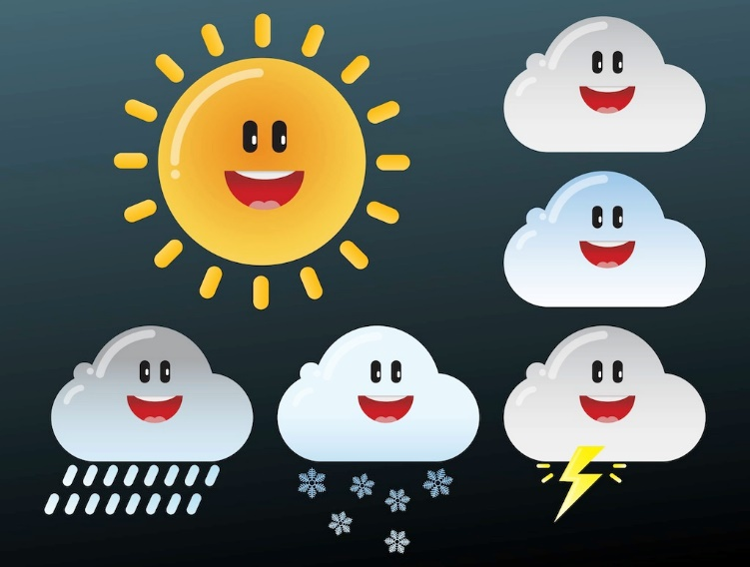

What weather do you like?
Can you tell what weather you don’t like?
How many clouds are there in the photo?
Does it rain a lot in your country?

