Ex A1 Weather
Name: ____________________________ Surname: ____________________________ N^{ber}: ____ Grade/Class: _____
Assessment: _____________________________ | Date: ___________________________________________________
 | Teacher’s signature:  ___________________________ | Parent’s signature:  ___________________________

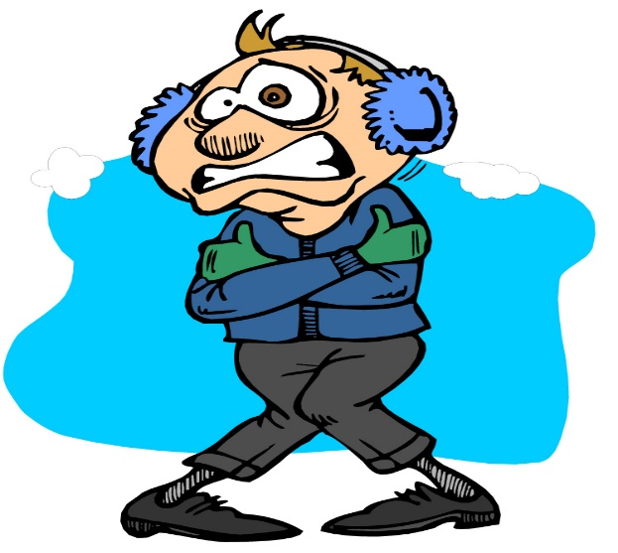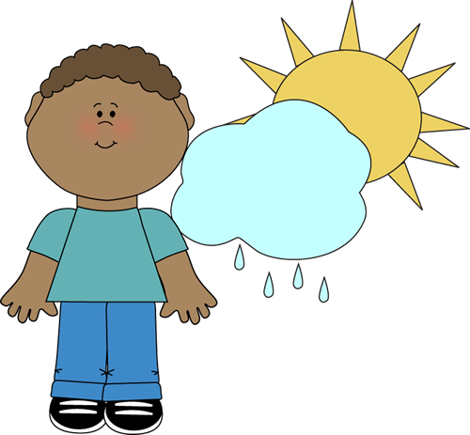

The man in the first picture is feeling really cold because it’s winter. The boy in the second picture is feeling hot because it is nice warm weather with just little rain.

Which of these two different types of weather do you like and why?
What is the weather like in country now?

