Ex A1 Weather
Name: ____________________________ Surname: ____________________________ N^{ber}: ____ Grade/Class: _____
Assessment: _____________________________ | Date: ___________________________________________________
 | Teacher’s signature:  ___________________________ | Parent’s signature:  ___________________________

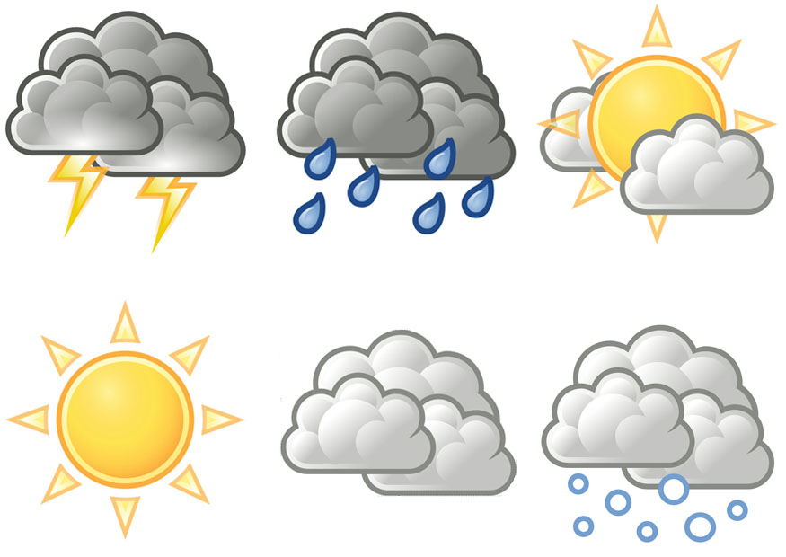

Look at these different weather symbols and tell me what kind of weather they show.
For example, the first symbol on the top shows a thunderstorm.

Now you tell me by pointing at the weather symbol.

