Ex A1 Weather
Name: ____________________________ Surname: ____________________________ N^{ber}: ____ Grade/Class: _____
Assessment: _____________________________ | Date: ___________________________________________________
 | Teacher’s signature:  ___________________________ | Parent’s signature:  ___________________________

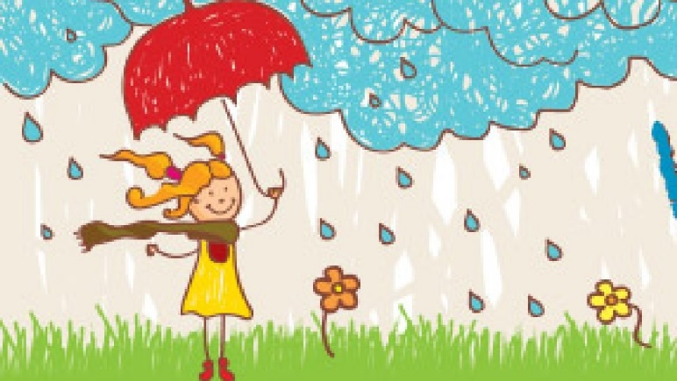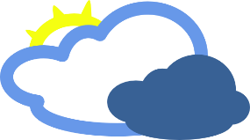

Here is a picture of Jane. She is holding an umbrella because it is raining and it is very cold too.

Look at the next picture and tell me what the weather will be like tomorrow.
Will it be a rainy day again?
Will it be a hot and sunny day?

