Ex. A1 Weather
Name: ____________________________ Surname: ____________________________ N^{ber}: ____ Grade/Class: _____
Assessment: _____________________________ | Date: ___________________________________________________
 | Teacher’s signature:  ___________________________ | Parent’s signature:  ___________________________

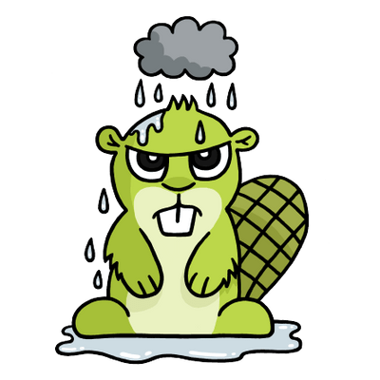

Look at these four pictures. They show four different types of weather.

Can you tell me what do you like doing when the weather is cold?
When is it rainy?
When is it hot?
When is it snowy?

