Exercise 1 A1 Weather
Name: ____________________________ Surname: ____________________________ N^{ber}: ____ Grade/Class: _____
Assessment: _____________________________ | Date: ___________________________________________________
 | Teacher’s signature:  ___________________________ | Parent’s signature:  ___________________________

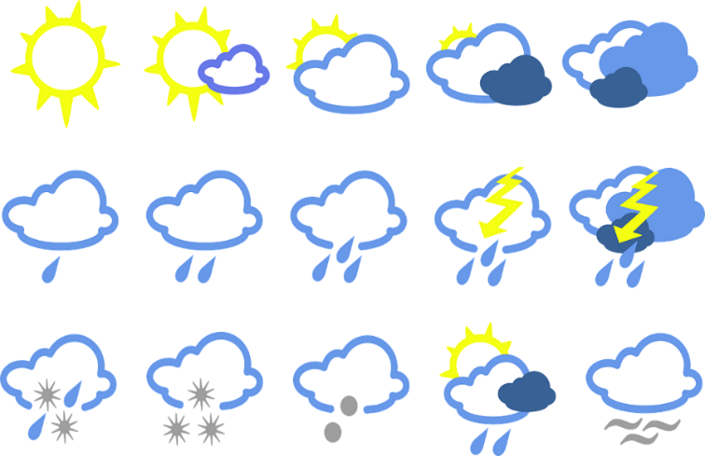
Choose the correct answer:

1. ... is water that falls from the sky.
a. Cold b. Rain c. Wet
2. When it is ..., it is not cold and not hot.
a. cold b. warm c. hot
3. When the temperature is low, it is ... .
a. cold b. hot c. warm
4. The ... is moving air – it blows our hair and the leaves on plants.
a. cloud b. snow c. wind
5. A ... is white or grey and is high in the sky.
a. cloud b. cold c. storm

Key: 1.b 2.b 3. a 4. c 5. A

