Exercise 2 A1 Weather
Name: ____________________________ Surname: ____________________________ N^{ber}: ____ Grade/Class: _____
Assessment: _____________________________ | Date: ___________________________________________________
 | Teacher’s signature:  ___________________________ | Parent’s signature:  ___________________________

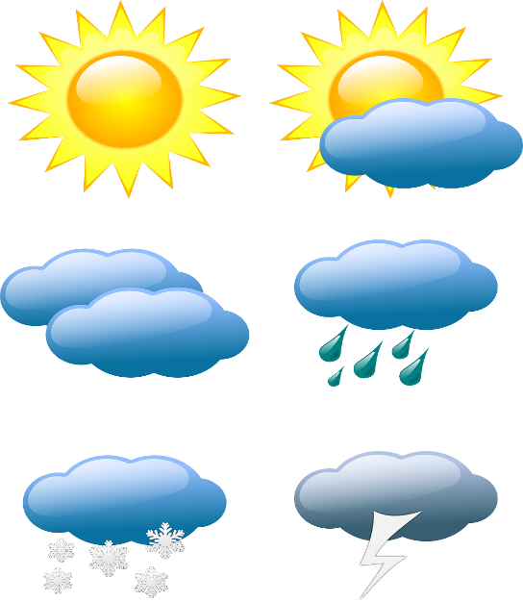
Choose the correct answer:
1. After it rains, the ground is ... .
a. cold b. fog c. wet
2. The ... rises in the morning and sets at night.
a. hot b. sun c. wind
3. ... is like a cloud, but is near the ground.
a. Cold b. Dry c. Fog
4. In a ... there can be rain, thunder and lightning.
a. fog b. rain c. storm
5. When it has not rained recently, the ground is ... .
a. cloud b. dry c. wet

Key: 1. C 2. B 3. C 4. C 5. B

