Exercise 3 A1 Weather
Name: ____________________________ Surname: ____________________________ N^{ber}: ____ Grade/Class: _____
Assessment: _____________________________ | Date: ___________________________________________________
 | Teacher’s signature:  ___________________________ | Parent’s signature:  ___________________________

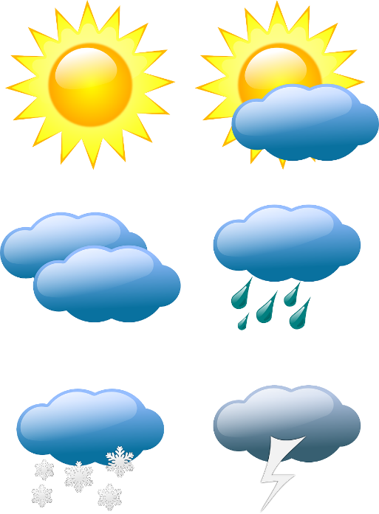
Complete the gaps with the correct weather word.
dry / cold and icy / warm / rain / cloud / sun

1. If the temperature is low, it is………
2. The …….is big and yellow. It rises in the morning and sets at night
3. When it is…... it is quite hot, but not too hot.
4. A……….is a white or grey shape in the sky.
5. …………….is water that falls from the sky.
6. When it has not rained recently, the ground is……..

Key:
1 cold and icy 2 sun 3. warm 4. cloud 5. rain 6. dry

