Ex. 5 A1 weather
Name: ____________________________ Surname: ____________________________ N^{ber}: ____ Grade/Class: _____
Assessment: _____________________________ | Date: ___________________________________________________
 | Teacher’s signature:  ___________________________ | Parent’s signature:  ___________________________

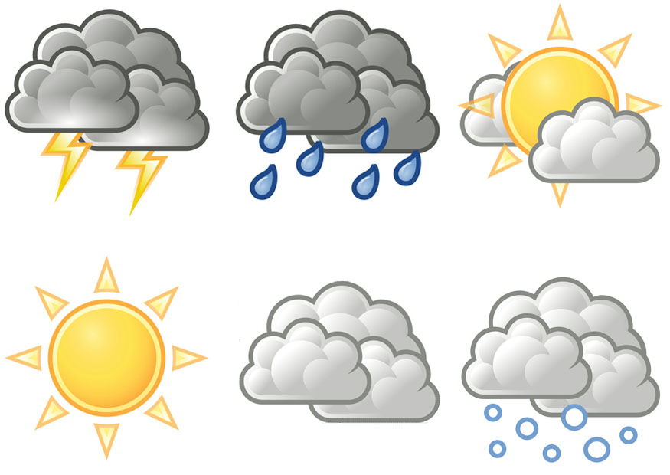
Write 5 weather words you can see in this picture.
e.g. sun, sunny etc.
1.___________________________________
2. ___________________________________
3. ___________________________________
4.____________________________________
5.____________________________________

