TOPIC: Weather | SUBTOPICS: Vocabulary | LEVEL: A1
Name: ____________________________ Surname: ____________________________ N^{ber}: ____ Grade/Class: _____

DRAW LINES TO MATCH THE WEATHER SYMBOLS WITH THE CORRECT WORD:

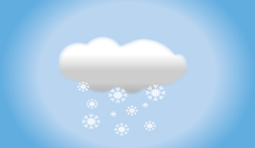 SUNNY

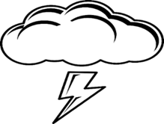 RAINY

SNOWY

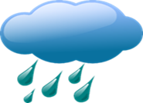 CLOUDY

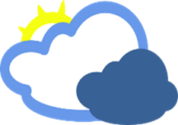 THUNDER

