TOPIC: Weather | SUBTOPICS: | LEVEL: A1
Name: ____________________________ Surname: ____________________________ N^{ber}: ____ Grade/Class: _____

What will the weather be like the following weekdays? The first letter of the word is written at the beginning.
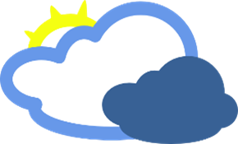 Monday: C _ _ _ _ _
Tuesday: T _ _ _ _ _ _
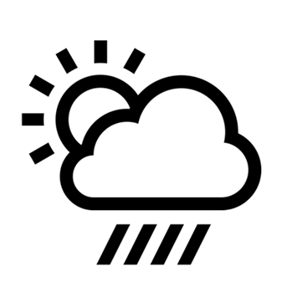 Wednesday: S _ _ _ _ , c_ _ _ _ _, r_ _ _ _
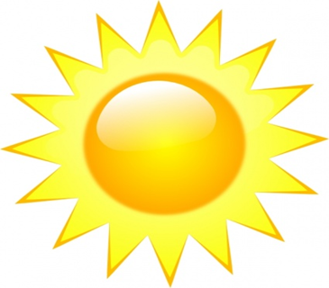 Thursday : S_ _ _ _
KEY:
Monday- cloudy Tuesday –thunder Wed- sunny/rainy/ cloudy Thursday-sunny

