TOPIC: Weather | SUBTOPICS: Vocabulary –weather symbols | LEVEL: A1
Name: ____________________________ Surname: ____________________________ N^{ber}: ____ Grade/Class: _____

Choose the correct answer:
cold rain warm cloud wind

1. ... is water that falls from the sky.
2. When it is ..., it is not cold and not hot.
3. When the temperature is low, it is ... .
4. The ... is moving air and it blows our hair
5. A ... is white or grey and is high in the sky.

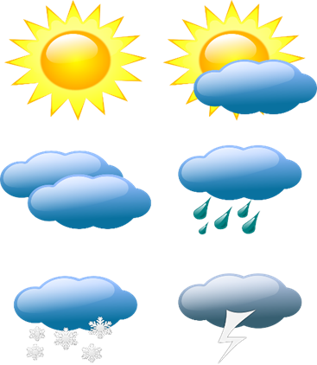
Write 3 words that describe the weather in your country:
____________ _____________ ______________

Key:1. Rain 2. Warm 3.cold 4. Wind 5. Cloud

