Ex.4 A1 Weather
Name: ____________________________ Surname: ____________________________ N^{ber}: ____ Grade/Class: _____
Assessment: _____________________________ | Date: ___________________________________________________
 | Teacher’s signature:  ___________________________ | Parent’s signature:  ___________________________

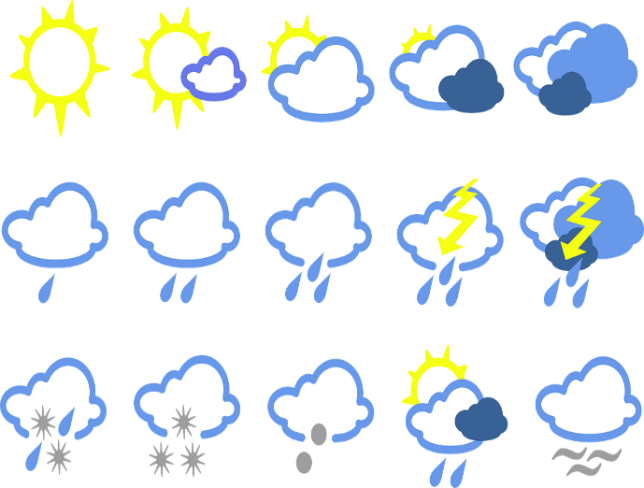
What is the weather like in your country?
Use the following words and write about the weather in your country in different seasons.

sunny, cloudy, rainy, foggy, snowy, very hot, cool, very cold, thunderstorms, windy, dry, wet

In winter --------------------------------------------------
In spring --------------------------------------------------
In summer-----------------------------------------------
In autumn------------------------------------------------

