Ex. 5 A1 Weather
Name: ____________________________ Surname: ____________________________ N^{ber}: ____ Grade/Class: _____
Assessment: _____________________________ | Date: ___________________________________________________
 | Teacher’s signature:  ___________________________ | Parent’s signature:  ___________________________

Answer the following questions:
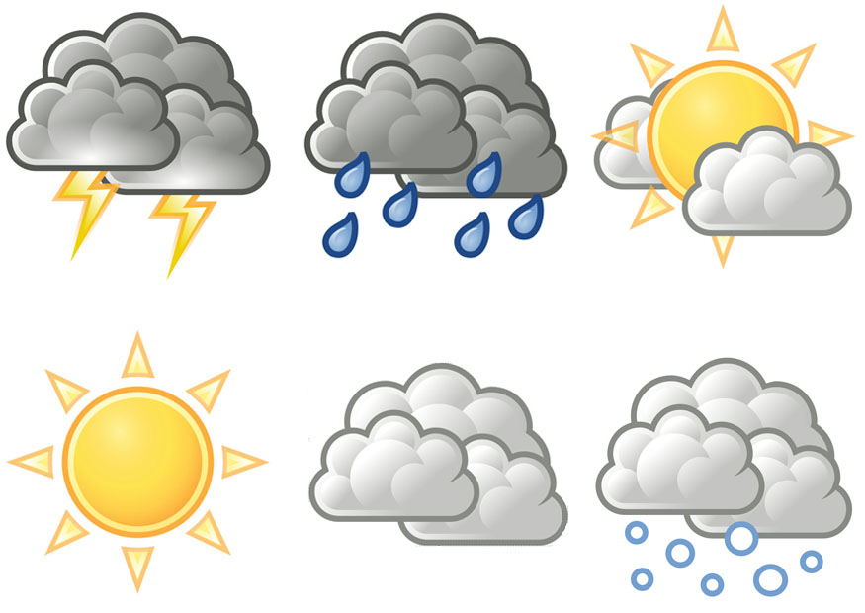

Which weather do you like the most?

Which weather do you dislike the most?

-----------------------------------------------------------------------------------------------------------------------------------------------------------
-

