Ex. 2 A2 Weather
Name: ____________________________ Surname: ____________________________ N^{ber}: ____ Grade/Class: _____
Assessment: _____________________________ | Date: ___________________________________________________
 | Teacher’s signature:  ___________________________ | Parent’s signature:  ___________________________

Listen and match the type of weather with the cities written below:
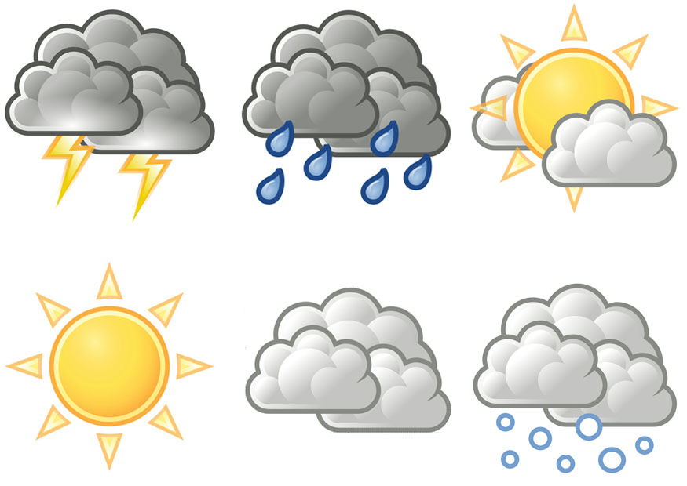

- Athens a. rainy

- Madrid b. sunny

- Paris c. snowy

- Berlin d. cloudy

- London e. foggy

Key: 1-B 2-A 3-D 4-C 5-E

Transcript:
The weather forecast for Europe is quite interesting today as it will be different in many part of it. Starting with north and in particular Berlin, there will be heavy snow all over the city with freezing temperatures.
In London, the weather will be foggy and in the morning there will be some frost.
Moving to Paris, it will be rainy with floods until late at night.
In Madrid, it will be cloudy but without rains while the weather in Athens will be mainly sunny with high temperatures.

